KIS MOBILE TRADING USERS MANUAL

CONTENT
I. ACCOUNT MANAGEMENT 4
1. Login to MTS 4
2. Change language 7
3. Account information 10
4. Change login password 12
5. Change order password 14
6. Account settings 18
7. Logout 21
II. favorite list 22
1. Create a new favorite list 22
2. Lookup for favorite lists 23
3. Add a new securities code to the list 25
4. Manage favorite list 28
4.1 Sort the securities list 28
4.2 Edit securities list in favorite lists 29
4.3 Edit the favorite list name 31
5. Manage all favorite lists 32
III. RANKING 34
IV. orders 35
1. Normal order 35
2. Stop order 41
3. Advance order 45
4. Lookup order history 47
5. Modify/Cancel orders 48
5.1 Modify orders 49
5.2 Cancel orders 51
6. Speed order 52
V. Securities information 58
1. Summary 59
2. Bid/Offer 60
3. Chart 61
4. Quote 62
5. Daily/weekly/monthly quote 63
6. Foreigner 64
7. News 65
8. Business info 66
VI. Alarms 67
1. Create a new alarm 67
2. Edit and delete alarms 69
VII. Customer Services 72
1. Equity 72
1.1 Stock balance 72
1.2 Account balance 74
1.3 Withdraw money 75
1.4 Transfer cash btw main/sub 77
1.5 Transfer stock 79
1.6 Secured loan 82
1.7 Rights subscription 85
2. Derivatives 86
2.1 Derivatives information 86
2.2 Daily balance 87
2.3 Risk ratio 88
2.4 Today open positions 89
2.5 Daily profit/loss and cumulative profit/loss 90
2.6 History 92
2.7 Withdraw money 95
2.8 Transfer cash btw main/sub 97
2.9 Deposit IM 99
2.10 Withdraw IM 101

ACCOUNT MANAGEMENT

Login to MTS
After download K-mobile application to mobile phones, customers access the application

The login screen will display:
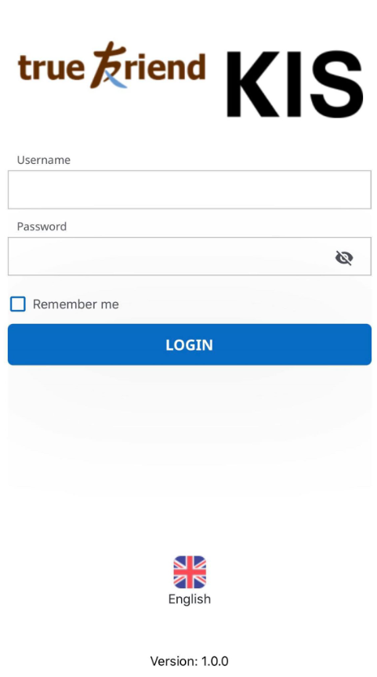
To login to customers’ account, please follow the following steps:
Step 1: Enter “Username” registered with KIS
Step 2: Enter “Password” associated with the account
Customers select “Remember me” to save the username for the next login
Step 3: Click on “LOGIN” and the system will display the OTP screen
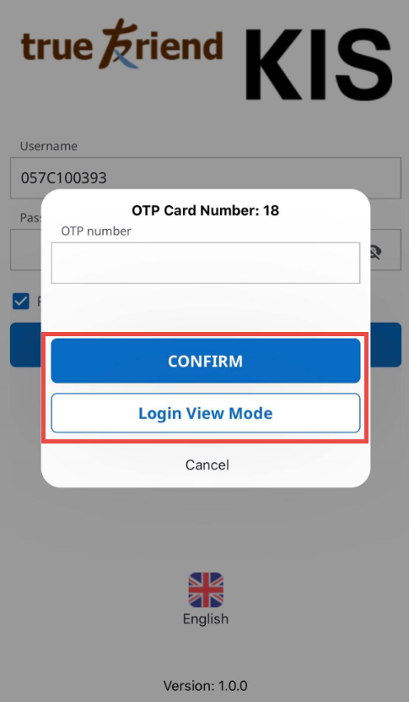
Step 4: Enter the OTP value associated from provided OTP card on “OTP number”
- To customers who first download and use K-mobile, the system will send a SMS to their phones to inform first-time OTP password and automatically activate “Using mobile OTP” in settings. After the first login, customers will receive an OTP notification on their mobile phones for every login
Step 5: Click on “CONFIRM” to login to customers’ KIS account and use the application
In case of no transaction needed, customers could click on “Login View Mode” to view market, chart… related information. If customers want to place orders or trade, they will need to exit the “Login View Mode” and login with OTP as usual
After logging in successfully, “Market” screen will be displayed
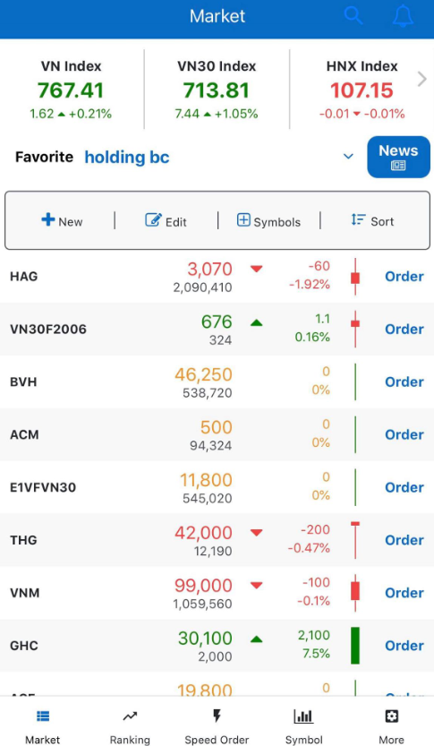

Change language
Customers change display language by clicking on the language symbol from the login screen:
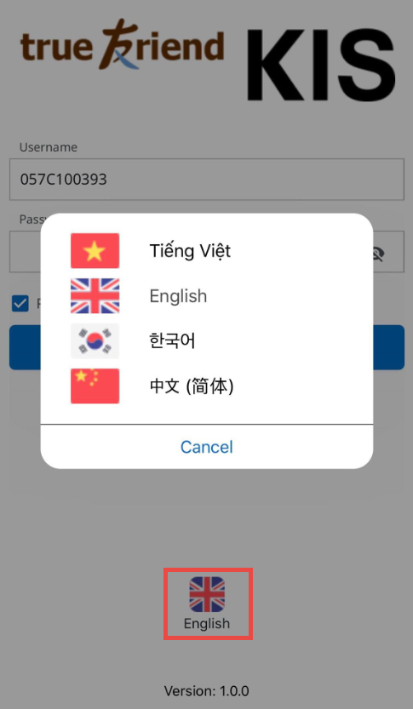
Or after logging in, clicking on “More/Setting” to select a desired language:
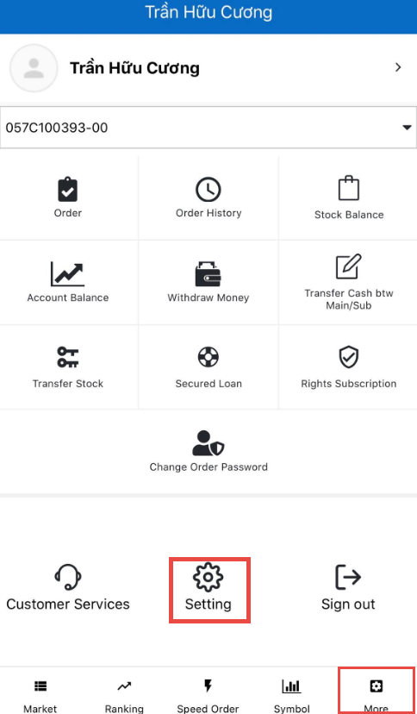
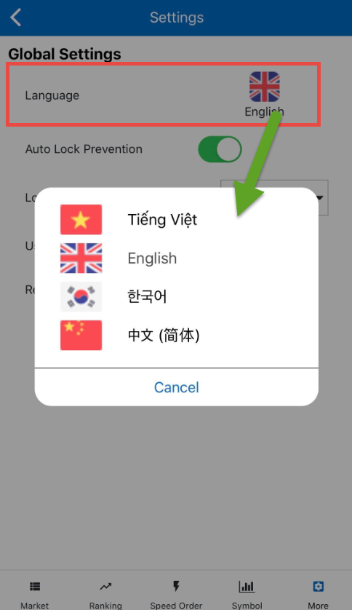

Account information
Customers access “More” at the bottom bar and select “Username” at the top to view account information being logged in:
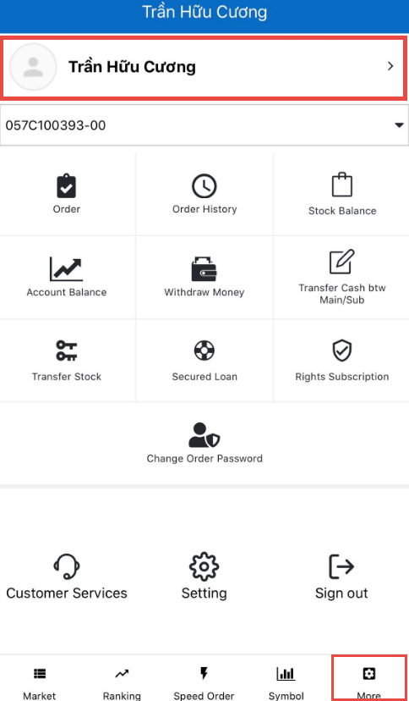
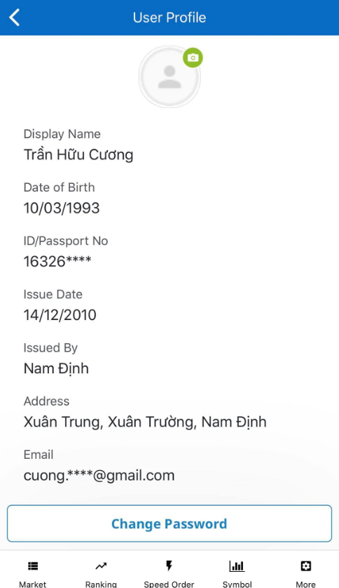

Information of account owner will be displayed. Some of the information about ID/Passport Number, email address and phone number can only be showed partially.

Change login password
Customers who want to change their login password could follow the following steps:
Step 1: Click on 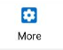 from the bottom bar
Step 2: Click on the username
Step 3: Click on “Change Password”
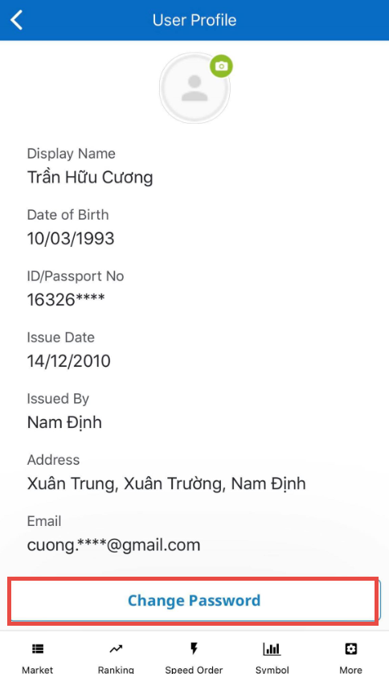
Step 4: Choose “Change Login Password” and the system will display a form for customers to change their login password:
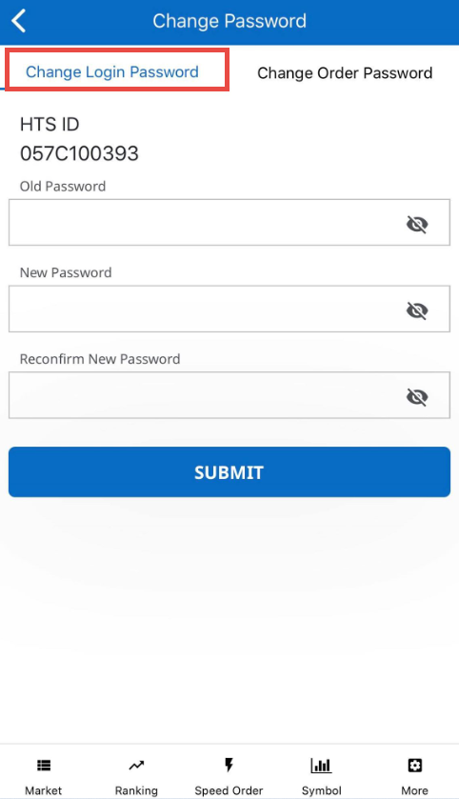

- Enter the “Old Password” being used.
- Enter a “New Password” wanted to change
- Enter the new password on “Reconfirm New Password”
- Click on “Submit” to complete chaging password or click on to cancel the action

Change order password
Customers who want to change their order password could perform in 2 ways:
Option 1:
Step 1: Click on from the bottom bar
Step 2: Click on “Change Order Password”
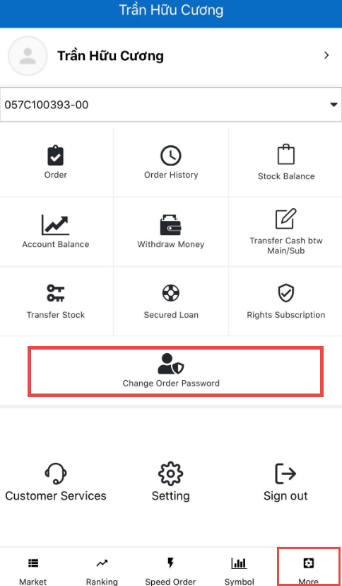
The system will display a form for customers to change their order password:
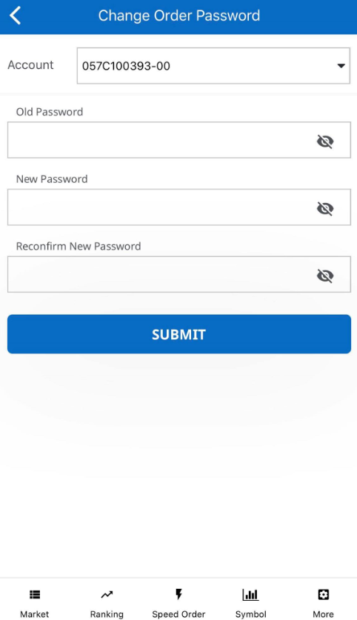
Step 3:
- Enter the “Old Password” being used.
- Enter a “New Password” wanted to change
- Enter the new password on “Reconfirm New Password”
- Click on “Submit” to complete chaging password or click on to cancel the action
Option 2:
Step 1: Click on from the bottom bar
Step 2: Click on the username
Step 3: Click on “Change Password”
Step 4: Choose “Change Order Password” and the system will display a form for customers to change their order password:
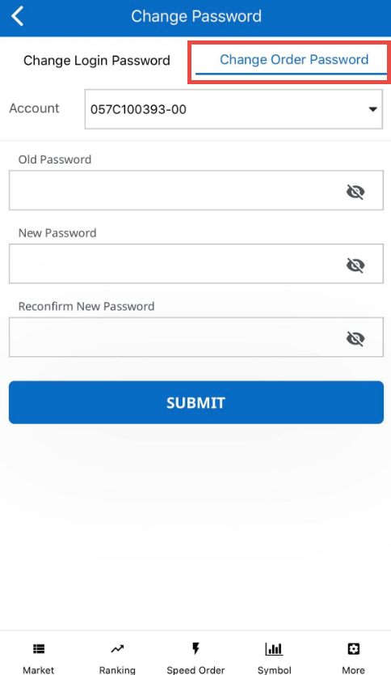

- Enter the “Old Password” being used.
- Enter a “New Password” wanted to change
- Enter the new password on “Reconfirm New Password”
- Click on “Submit” to complete chaging password or click on to cancel the action

Account settings
Customers change settings for some features cho the account being used by clicking on “More”/ “Setting”
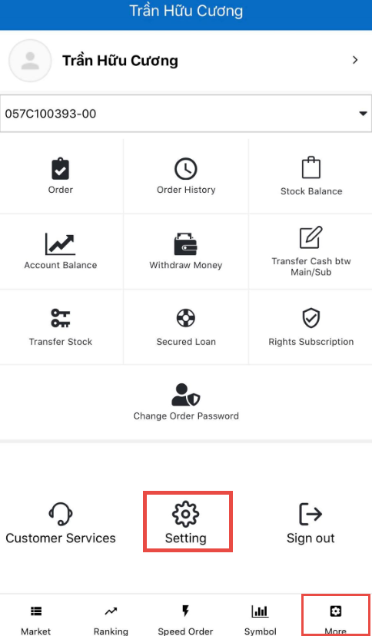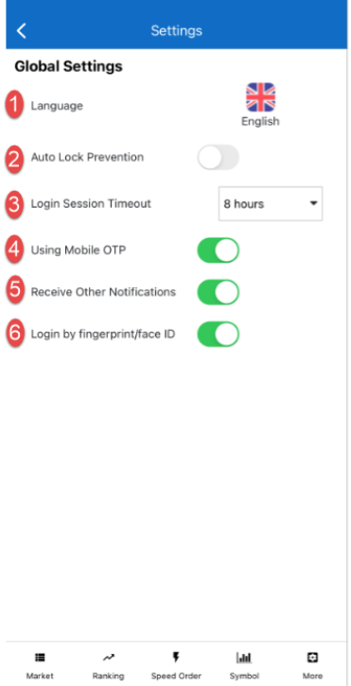

- Language: Customers change language being used to another one
- Auto Lock Prevention: This feature allows customers’ mobile phone not to lock the screen according to the set waiting time during the trading time
- Login Session Timeout: This feature allows customers to set time for application to automatically logout
For example: The login timout session is 30 minutes. After 30 minutes, if customers do not have any performance on the application, the system will automatically logout the account
- Using OTP Mobile: This feature allows the system to send a message to customers’ mobile phones notifying the OTP number used to login to the application. Customers will no longer need to bring the OTP card and they can login anywhere and anytime.
- Receive Other Notifications: This feature allows customers to regisfer notifications of any matched orders and alarms and they will be sent to customers’ mobile phones.
- Login by fingerprint/face ID: This feature allows customers to login by fingerprint/face ID and don’t need to typing password & OTP.

Logout
Customers who want to logout the application could follow the following steps:
Step 1: Click on from the bottom bar
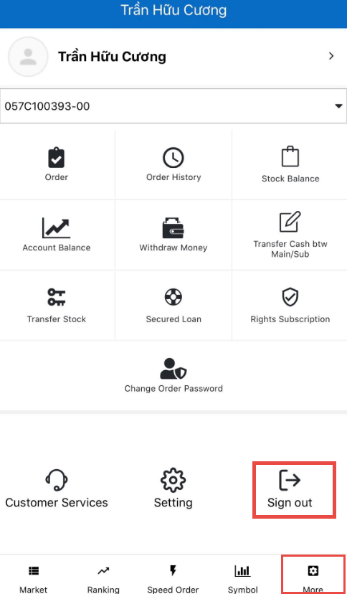
Step 2: Select “Logout” to exit the application

favorite list
Favorite lists allow customers to make lists of securities codes that they are interested in. Customers can set maximum 50 securities codes for 1 Favorite list
Customers could click on “Symbol” to view the details of a securities codes or click on “Order” to perform place orders for the chosen securities codes.

Create a new favorite list
From the Market screen, available favorite lists will be displayed. To add a new favorite list, customers follows the following steps:
Step 1: From the Market screen, click on
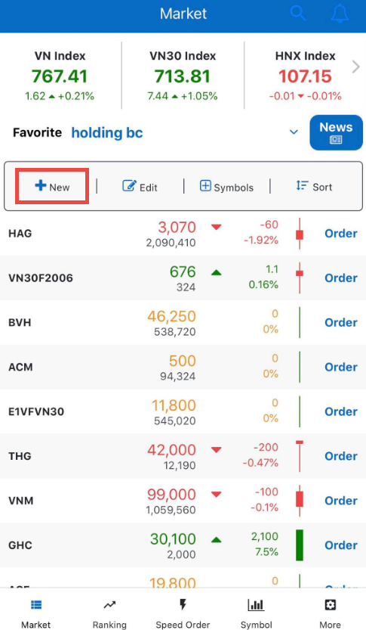
A pop-up screen will be displayed for customers to perform adding a new favorite list:
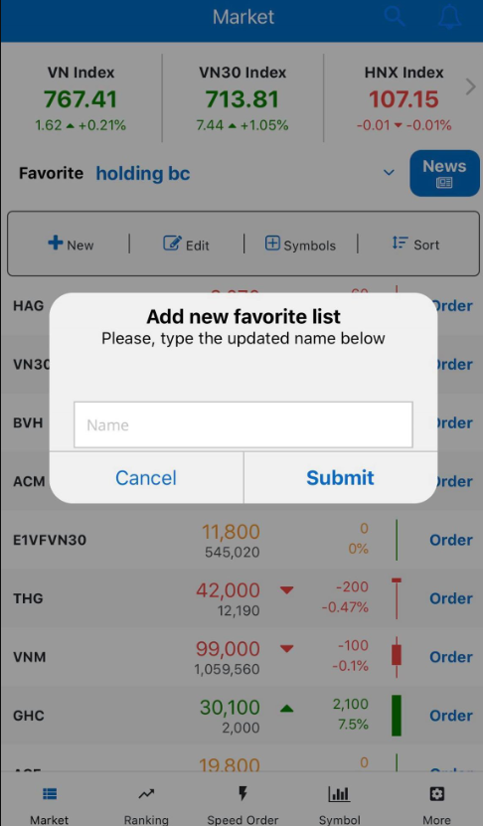
Step 2: Type in the name for the new favorite list
Step 3: Click on “Submit” to create a new list or “Cancel” to cancel the act

Lookup for favorite lists
Customers lookup for entire favorite list currently available on the Market screen by clicking on the down arrow next to the list name being displayed:
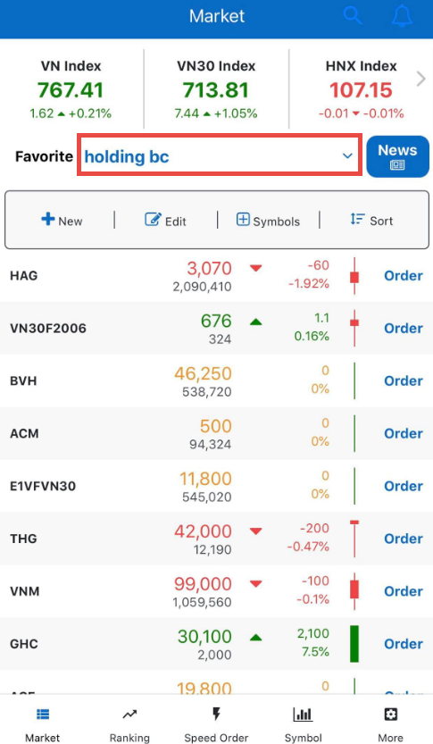
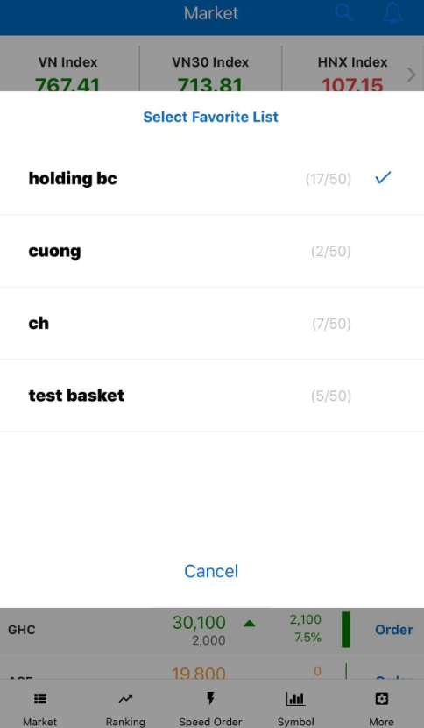
The pop-up screen will show all favorite lists current available and the number of securities codes in each list. Customers can scroll up or down to see the entire list.

Add a new securities code to the list
Customers add new securities codes to the favorite list being displayed by:
Step 1: Click on 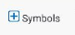
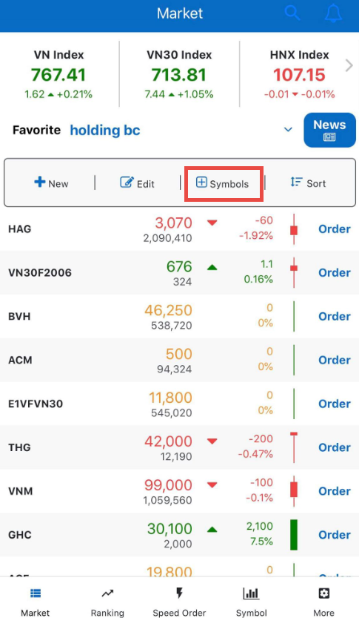
The system will display the entire list of securities codes on the market:
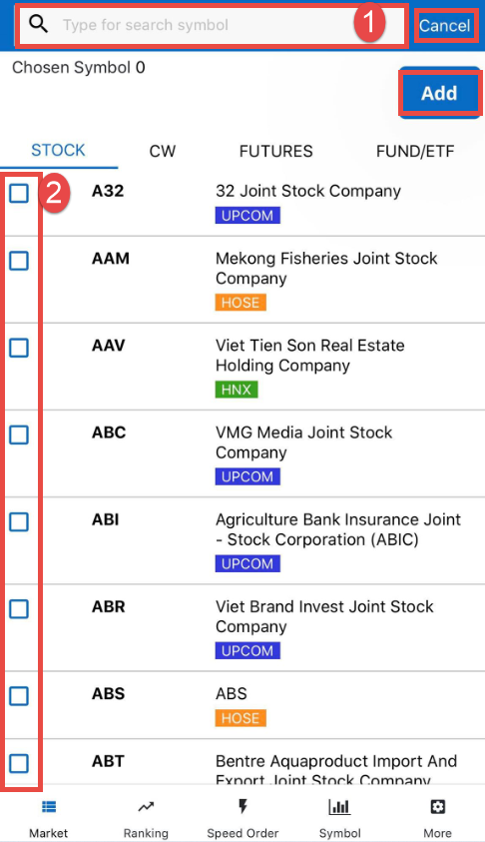
Step 2: Choose a securities type wanted to add. Currently there are 4 types: Stock, CW, Futures and Fund/ETF
Step 3: Choose a securities code to add
- Customers enter the desired securities code in the search bar (1) or tick the box (2) at the front of each securities code to add them to the list. The system allows customers to scroll down to see more securities code
Step 4: Click on “Add” to complete adding new securities codes or “Cancel” to cancel the act

Manage favorite list

Sort the securities list
Cusomers choose a sorting type by:
Step 1: Choose a favorite list
Step 2: Click on 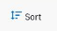 and the system will display sorting options: By Name, By Percentage, By Volume, By Price and No Sort
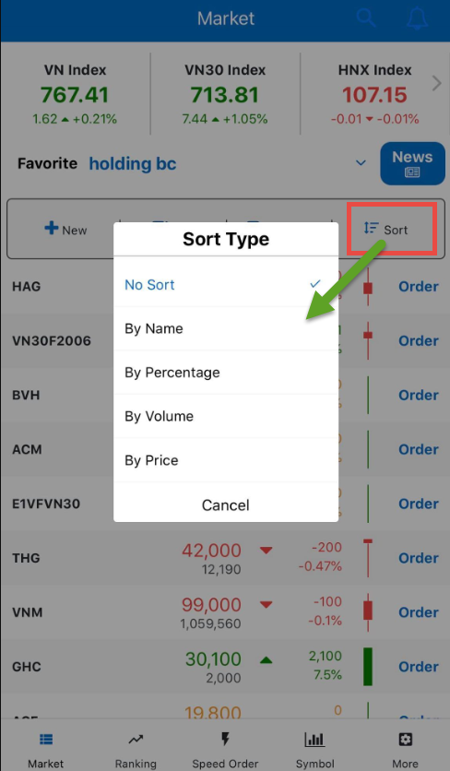
Step 3: Choose a sorting type. The system will organize the securities list of the chosen list

Edit securities list in favorite lists
Customers perform editing securities list in favortie lists by:
- Click on
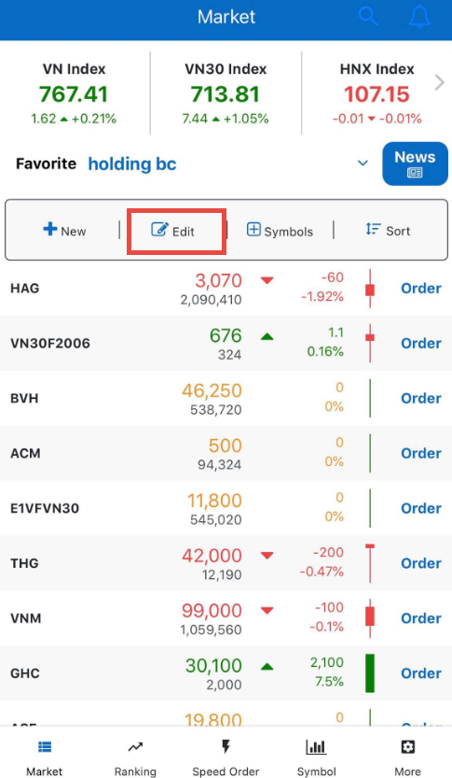
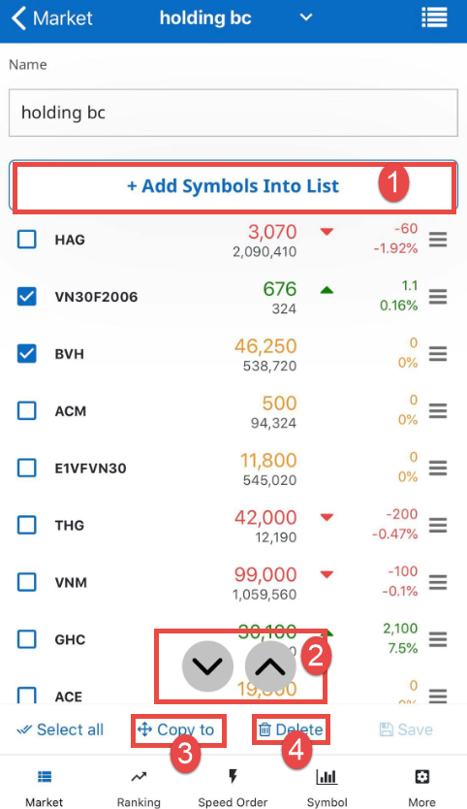

- To add new securities codes, customers click on “Add Symbols Into List” (1). The system will switch to the screen to add new securities codes.
- To move the securities codes position to the top or bottom of the list, customers could tick the codes and click on (2) to move the position.
- To copy the securities codes to other lists, customers tick the codes and click on “Copy to” (3) then select a list wanted to copy the codes to.
- To delete the securities codes from the list, customers tick the codes and click on “Delete” (4) to remove the chosen securities codes

Edit the favorite list name
Customers perform editing the name of the favorite list by:
Step 1: Choose a favorite list to edit
Step 2: Click on
The system will display the screen to edit favorite list
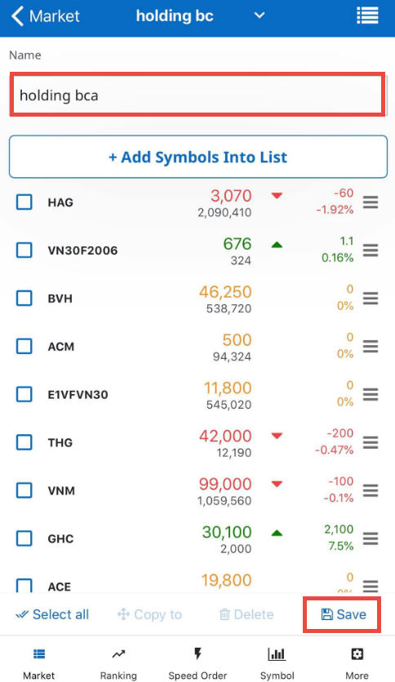
Step 3: Click on the “Name” box with the favorite list’s name
Step 4: Click on “Save” to save the new favorite list name

Manage all favorite lists
To manage all available favorite lists, customers could follow the following steps:
Step 1: Click on 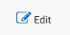
Step 2: Click on on the top right of the screen
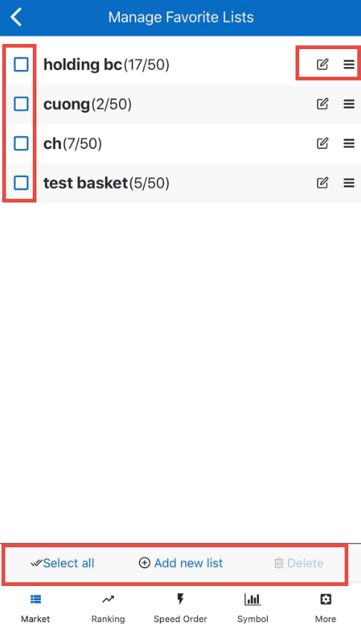
Step 3: Select an act with favorite lists
- Click on 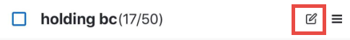 to edit the name of the chosen favorite list
- Drag and drop the list using 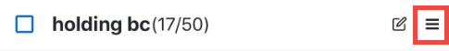 to move the position of the favorite list in the overall list
- Tick the favorite list and click on “Delete” to remove the chosen list or click on “Select all” and select “Delete” to clear all the lists
- Click on “Add new list” to create a new favorite list

RANKING
Customers access to view the ranking board of HOSE, HNX and UPCOM in the order of increasing or decreasing the change rate compared to the reference price.
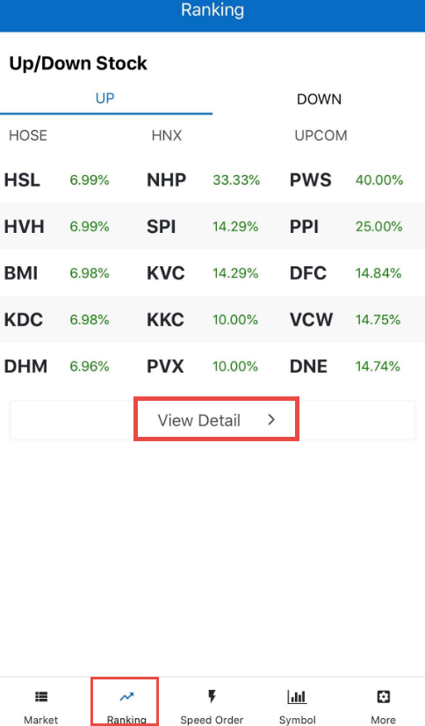
Customers could click on “View detail” to view a list of all rankings by exchange market
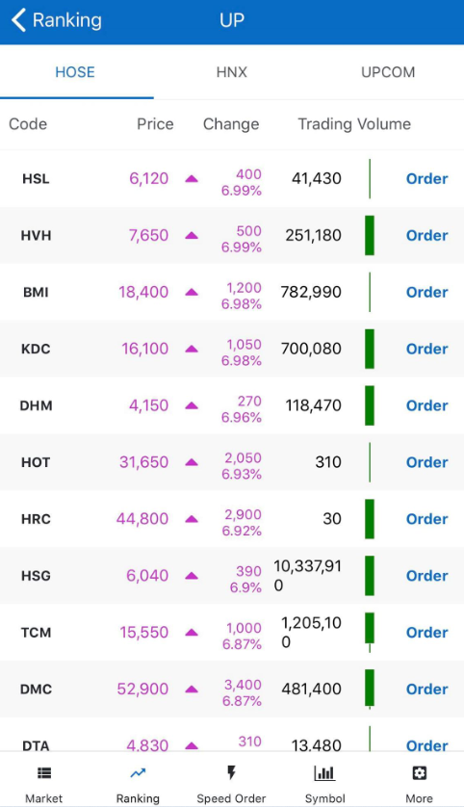
Customers could click on the “securities codes” to switch the screen where they can see details of the chosen securities codes or click on “Order” to perfom placing order for the chosen securities codes

orders

Normal order
Order screen is usually used to place orders for trading securities for HOSE, HNX and UPCOM
On K-mobile application, all screens have Order button so that customer could place orders more conveniently and quickly
Option 1
On the Market screen, customers could click on “Order” at any securities codes in the favorite list
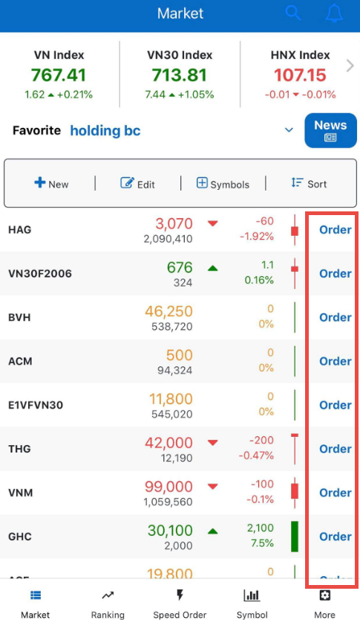
Option 2
On the Ranking screen, customers could click on “Order” at any securities codes in the ranking list

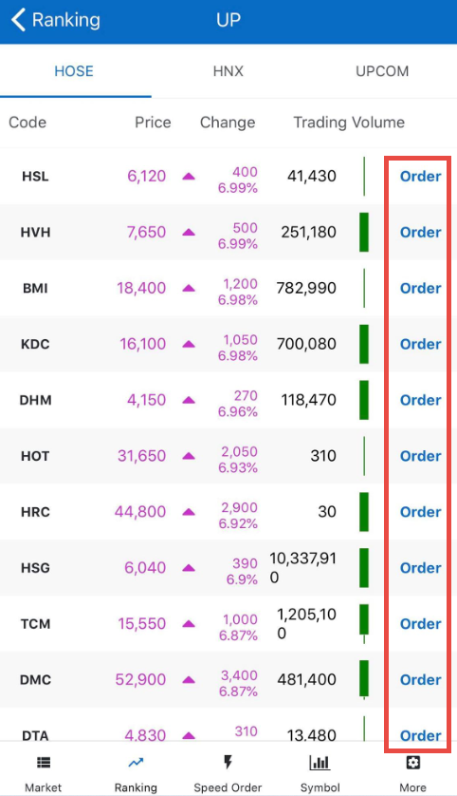
Option 3
On the securities details screen:
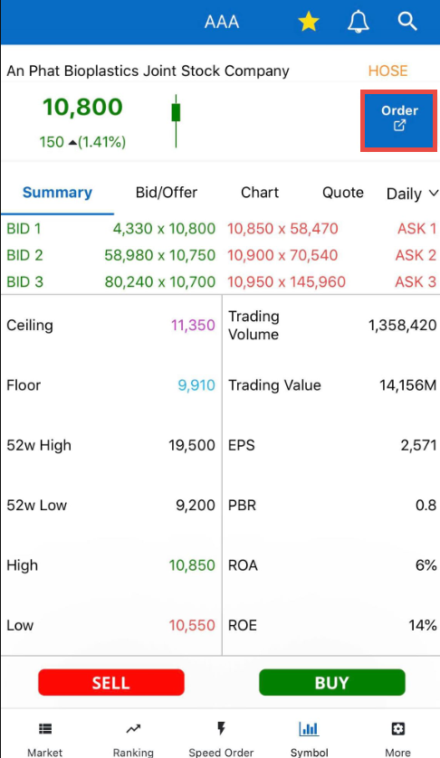
Option 4
From the “More” screen
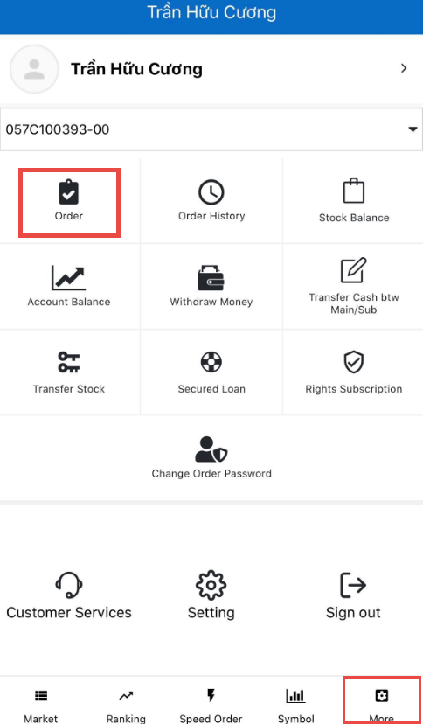
After clicking on one of the “Order” buttons, the system will display a screen to place normal orders
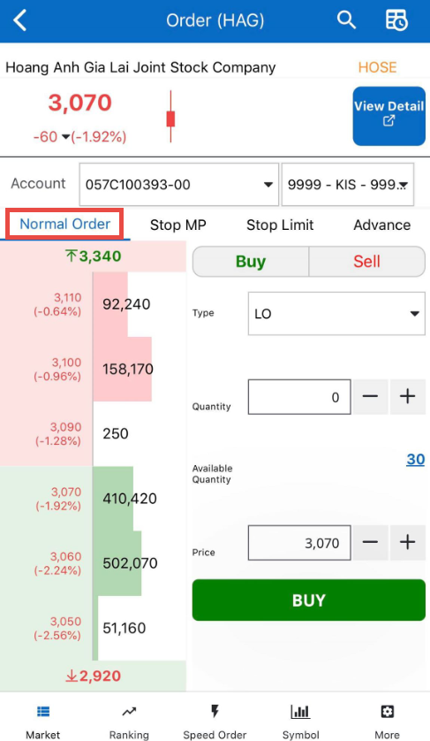
Steps to perform placing a normal order:
Step 1: At any Order screen, click onbutton to confirm the order type
Step 2: Enter order information: Account, Type, Quantity and Price
- Click on any bid/ask/ceiling/floor price, the order price will be automatically carried.
- Click on the Available Quantity and the Quanity will be automatically carried.
- Price and Quantity can be adjusted based on price tick/trading unit by using
Step 3: Click on “Buy/Sell” at the bottom of the order form to carry out the transaction
Step 4: Click on “Confirm” on the pop-up screen to perform placing order or “Cancel” to cancel the act
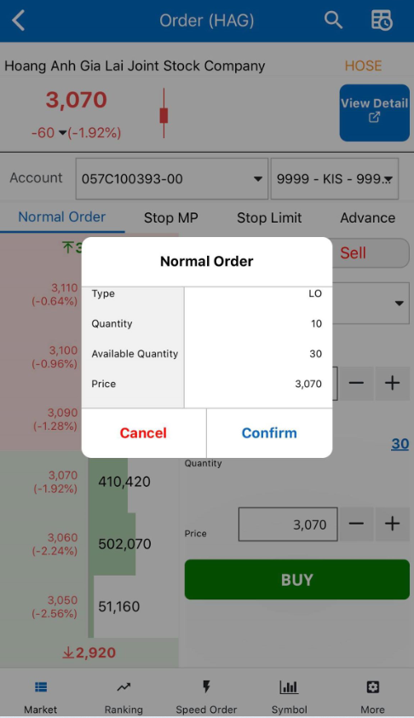
After placing the orders, customers can see the order history by clicking on on the top right corner of the order screen

Stop order
Stop order MP:
To perform placing a stop order, customers access the order screen and select Stop Order:
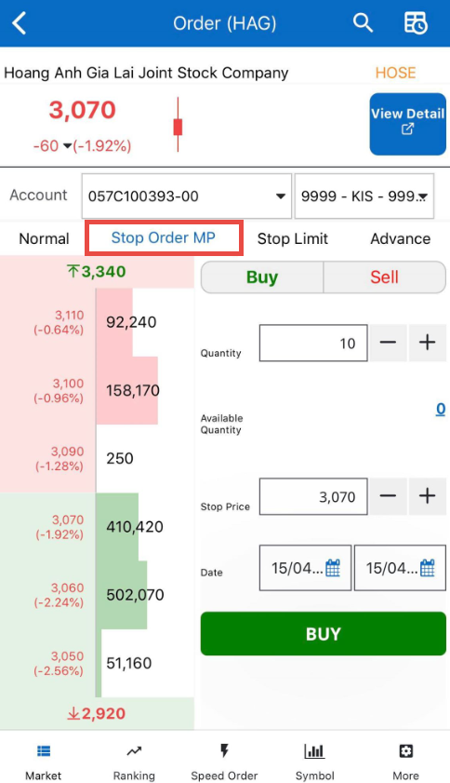
Step 1: At any Order screen, click on “Buy/Sell” button to confirm the order type
Step 2: Enter order information: Account, Quantity, Stop Price and Date
- Click on any bid/ask/ceiling/floor price, the order price will be automatically carried.
- Click on the Available Quantity and the Quanity will be automatically carried.
- Stop Price and Quantity can be adjusted based on price tick/trading unit by using
Step 3: Click on “Buy/Sell” at the bottom of the order form to carry out the transaction
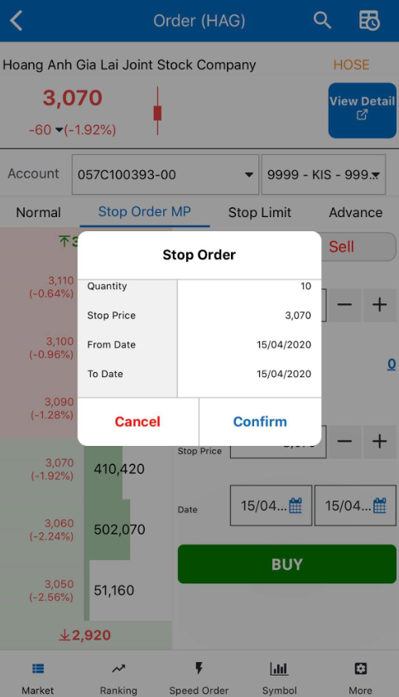
Step 4: Click on “Confirm” on the pop-up screen to perform placing order or “Cancel” to cancel the act

Stop limit order:
To perform placing a stop limit order, customers access the order screen and select Stop Limit Order:
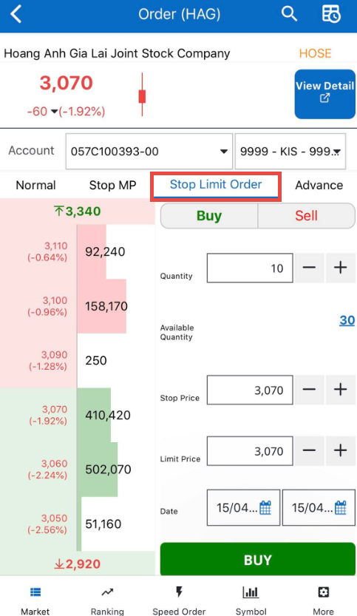
Step 1: At any Order screen, click on “Buy/Sell” button to confirm the order type
Step 2: Enter order information: Account, Quantity, Stop Price, Limit Price and Date
- Click on any bid/ask/ceiling/floor price, the order price will be automatically carried.
- Click on the Available Quantity and the Quanity will be automatically carried.
- Stop Price, Limit Price and Quantity can be adjusted based on price tick/trading unit by using
Step 3: Click on “Buy/Sell” at the bottom of the order form to carry out the transaction
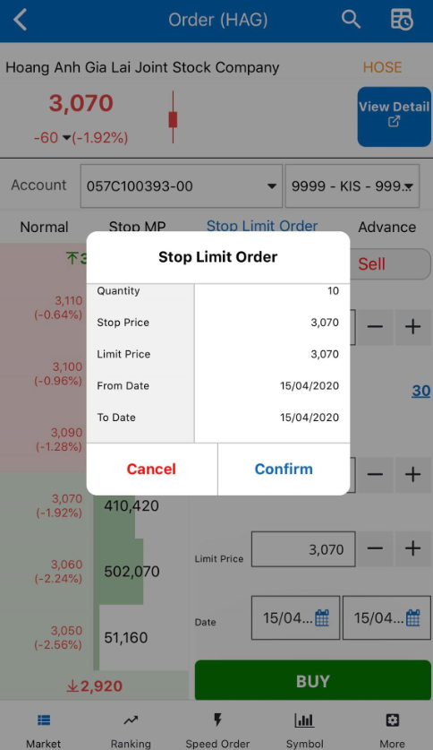
Step 4: Click on “Confirm” on the pop-up screen to perform placing order or “Cancel” to cancel the act

Advance order
To perform placing an advance order, customers access the order screen and select Advance Order
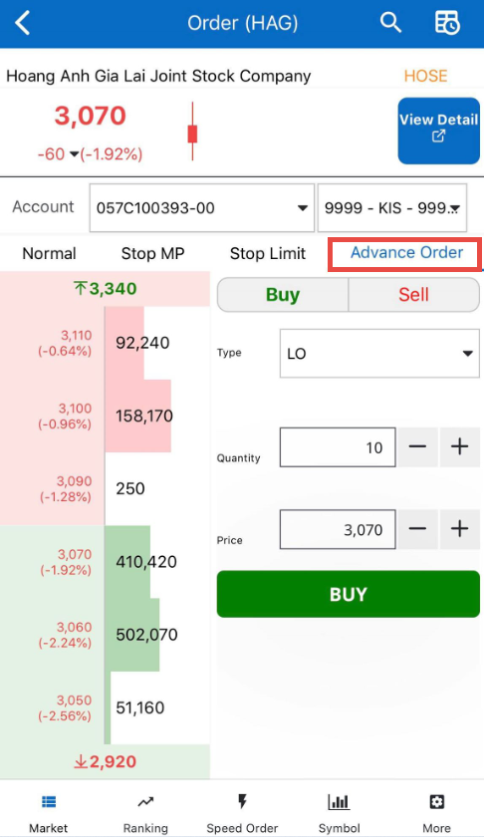
Step 1: At any Order screen, click on “Buy/Sell” button to confirm the order type
Step 2: Enter order information: Account, Quantity and Price
- Click on any bid/ask/ceiling/floor price, the order price will be automatically carried.
- Price and Quantity can be adjusted based on price tick/trading unit by using
Step 3: Click on “Buy/Sell” at the bottom of the order form to carry out the transaction
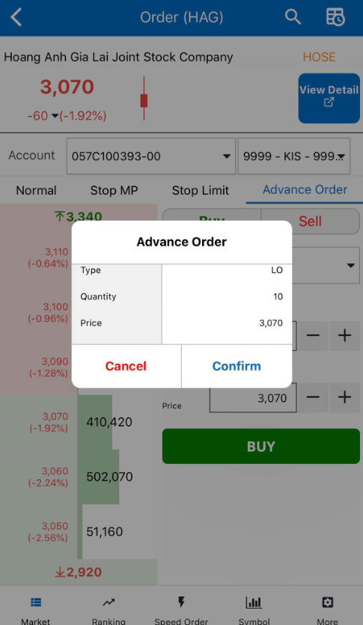
Step 4: Click on “Confirm” on the pop-up screen to perform placing order or “Cancel” to cancel the act.

Lookup order history
Customers after placing order can lookup for order history by:
Option 1: Click on on the top right corner of the order screen
Option 2: Click on “More” => select “Order History”
Customers could choose an order type (normal order, stop order, advance order) to lookup for orders information
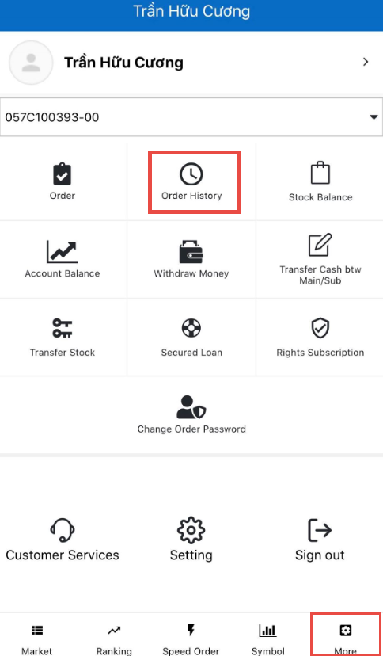

Modify/Cancel orders
Customers could choose an order type (normal order, stop order, advance order) to perform modify/cancel order.

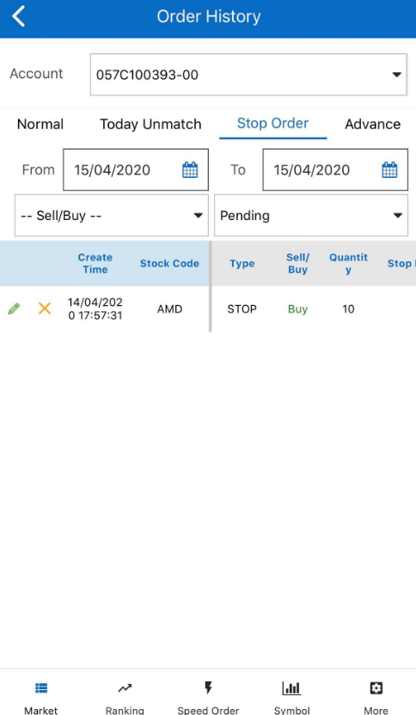

Modify orders
Steps to perform modifying order:
Step 1: Select an order type (normal order, stop order, stop limit order) wanted to edit
Step 2: Select an order number to edit
Step 3: Click on to move to the editing screen
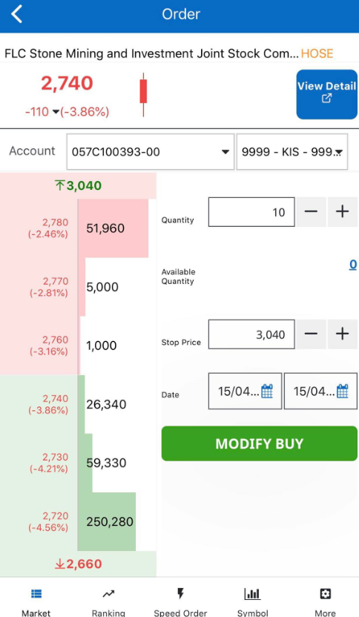
Step 4: Modify the price, quantity and date of the order
Step 5: Click on “Modify Buy” or “Modify Sell” to complete modifying orders
Step 6: Click on “Confirm” on the pop-up screen to complete modifying or “Cancel” to cancel the act
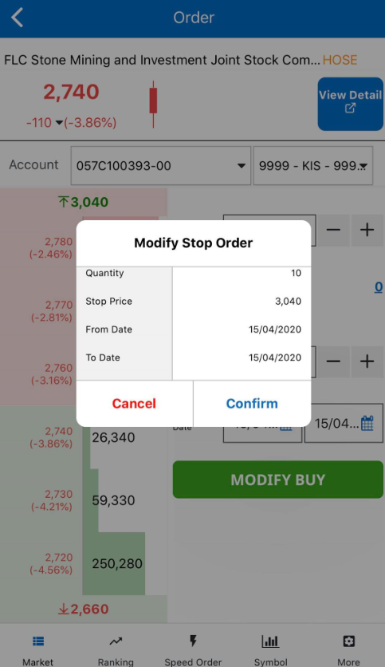

Cancel orders
Steps to perform cancelling order:
Step 1: Select an order type (normal order, stop order, stop limit order) wanted to cancel
Step 2: Select an order number to cancel
Step 3: Click on to move to the cancelling screen

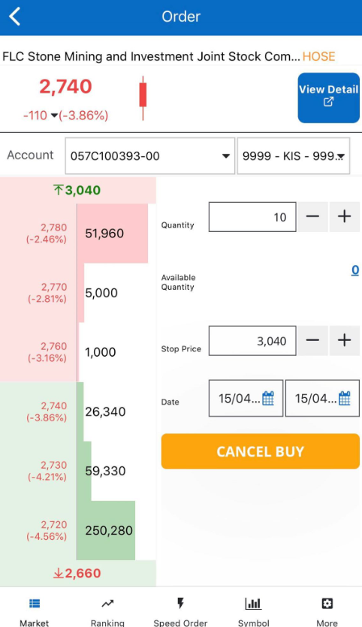
Step 4: Click on “Cancel Buy” or “Canel Sell” to complete cancelling orders
Step 5: Click on “Confirm” on the pop-up screen to complete canceling or “Cancel” to cancel the act

Speed order
Placing speed order:
To perform placing speed orders:
Step 1: Select on the bottom bar
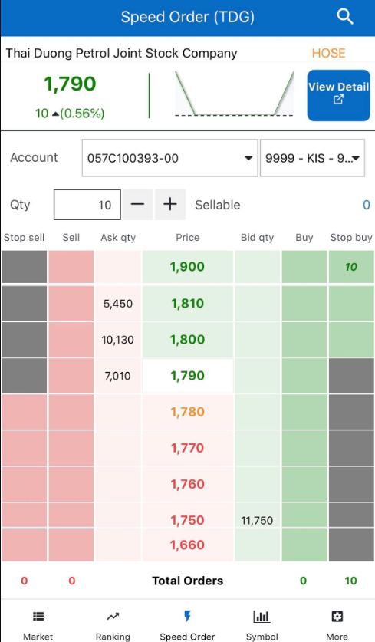

Step 2: Enter quantity
Step 3: Click on the cell having its order type (normal buy/sell orders, stop buy/sell orders) with a price associated that customers want to place their order. The system will automatically update the order quantity on the order column with the associated price. At the same time, it will update the total orders at “Total Orders”
For example: Customers want to place a stop order for 10 TDG at a stop price of 1900
Step 1: Click on speed order
Step 2: Enter quantity = 10
Step 3: Click on the column “Stop Buy” with the price of 1900 and then click on the cell to place the order
Modify speed order:
Customers modify speed order from the speed order screen by:
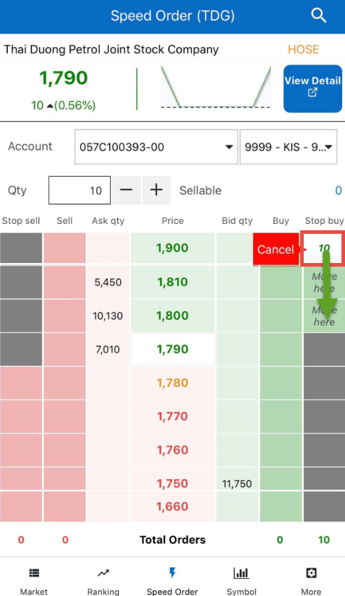
Step 1: Click on the cell containing the price and quantity that customers want to edit
Step 2: Click on a new cell that customers want to modify the old one to.
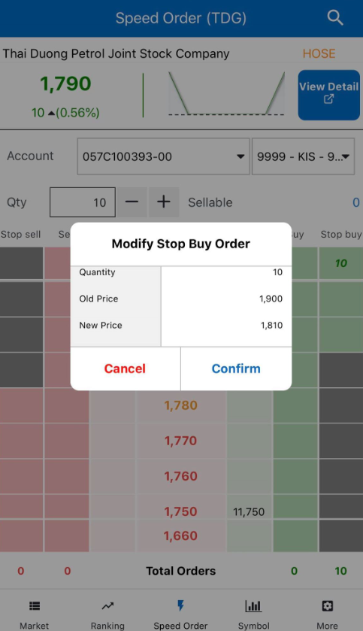
Step 3: Click on “Confirm” on the pop-up screen to complete modifying or “Cancel” to cancel the act
For example:
Step 1: Click on the quantity cell with 10 TDG at the price of 1900
Step 2: Click on the cell with a price of 1820
Step 3: Click on Confirm to accomplish modifying the price from 1900 to 1820
Cancel speed order:
Customers cancel speed order from the speed order screen by:
Step 1: Click on the cell containing the price and quantity that customers want to cancel
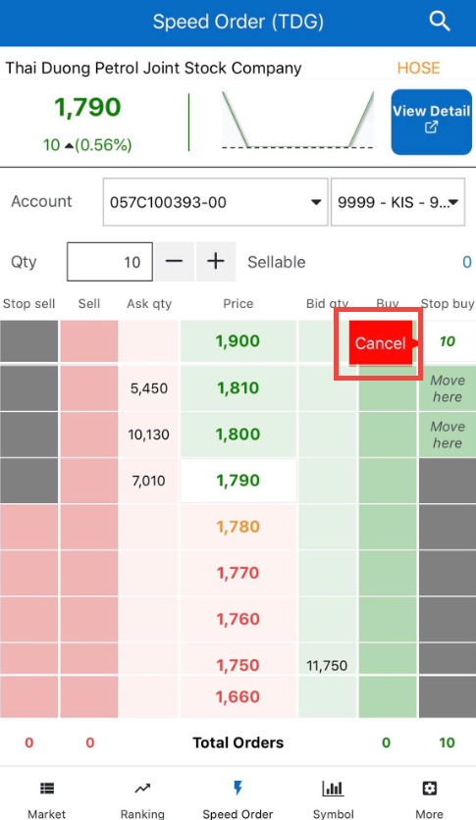
Step 2: Click on “Cancel” on the side or click on the total orders cell to remove all waiting orders
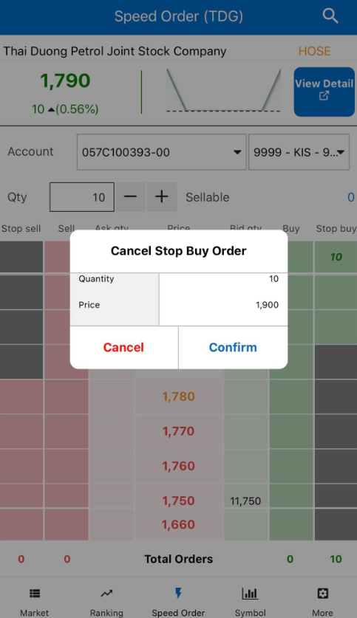
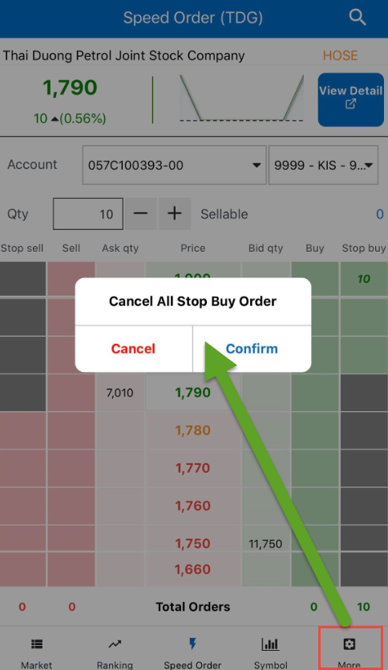
Step 3: Click on “Confirm” on the pop-up screen to complete cancelling or “Cancel” to cancel the act

Securities information
Customers track the details of any securities codes by clicking on 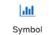
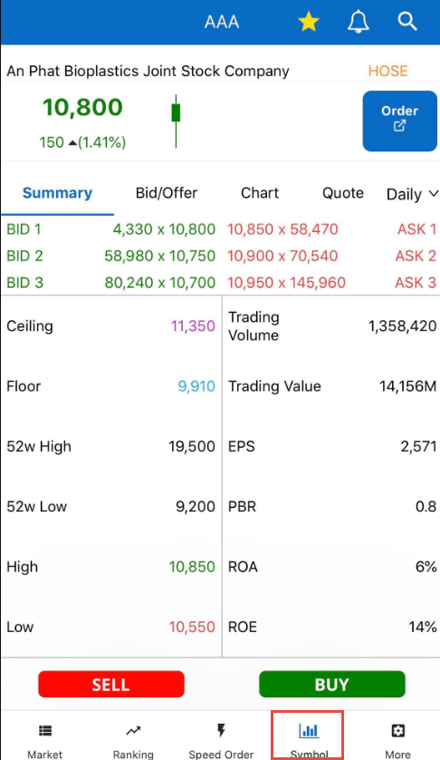

Summary
Summary screen will provide customers information about bid/offer, floor and ceiling price and other financial indicators related to the securities codes
Customers place orders by clicking on “Order” or “Buy”/“Sell” to switch to the trading screen
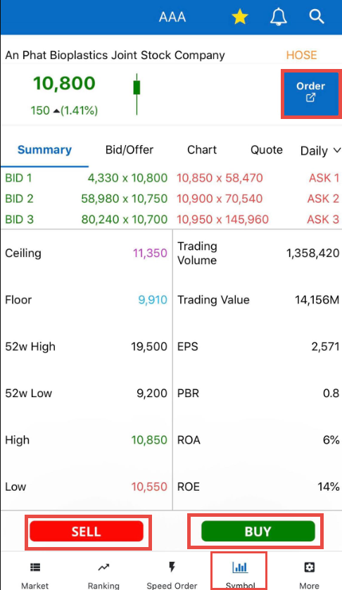

Bid/Offer
Bid/Offer screen provide information about bid/ask, floor and ceiling price, quote info and change rate as a chart
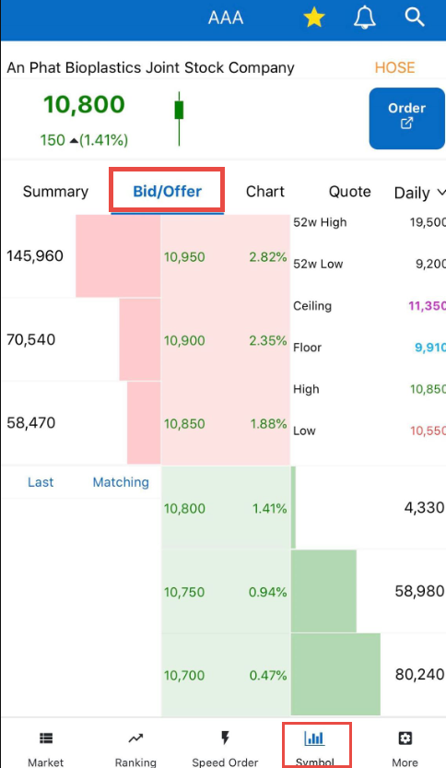

Chart
Chart screen provides a chart of matching order information of the chosen securities codes
The chart is drawn by tick, minutes, daily, weekly and monthly.
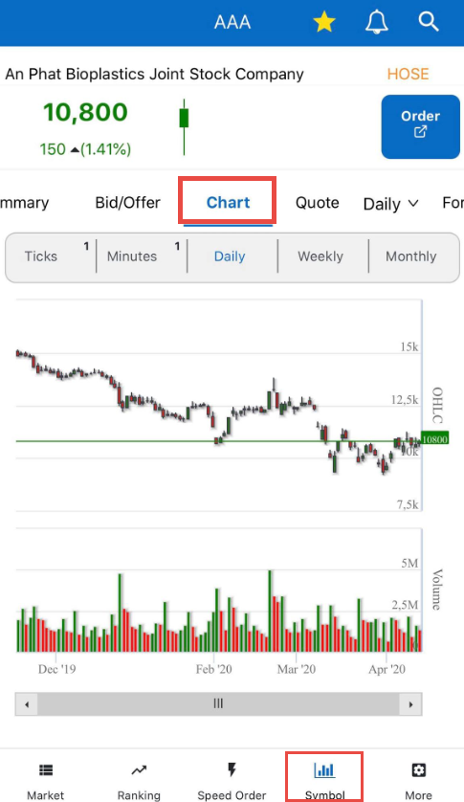

Quote
Quote screen provides details of matching order information (Time, Last, Change, Rate and Trading Volume) in real time during the trading day of the chosen securities codes
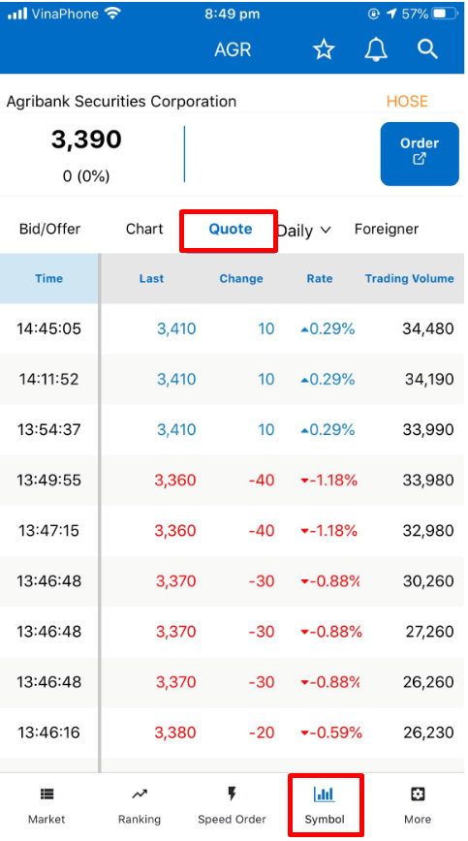

Daily/weekly/monthly quote
The screen provides matching information by day, week and month of the chosen securities codes. Customers click on “Daily” to select a desired time to see matching information.
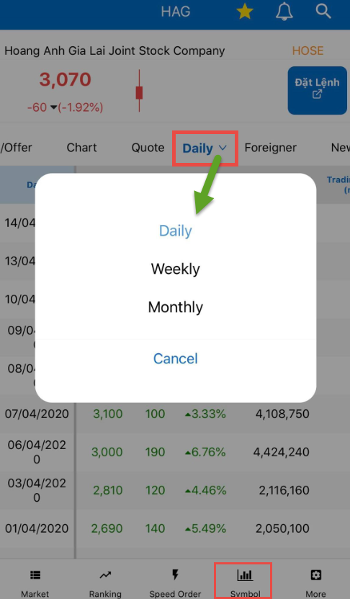

Foreigner
The screen provides information related to foreign investors trading such as Net Volume, Buy Volume, Sell Volume, Hold Volume, Hold Ratio and Buyable Ratio of the chosen securities codes
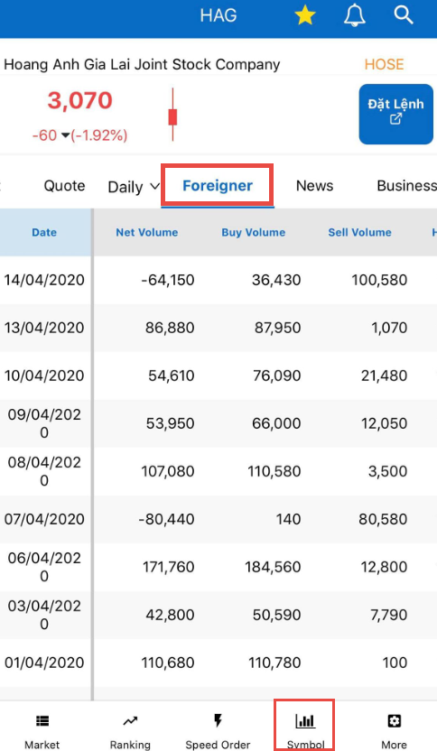

News
The screen provides articles and market information related to the chosen securities codes. Customers could click on the title of the articles to view the full version.
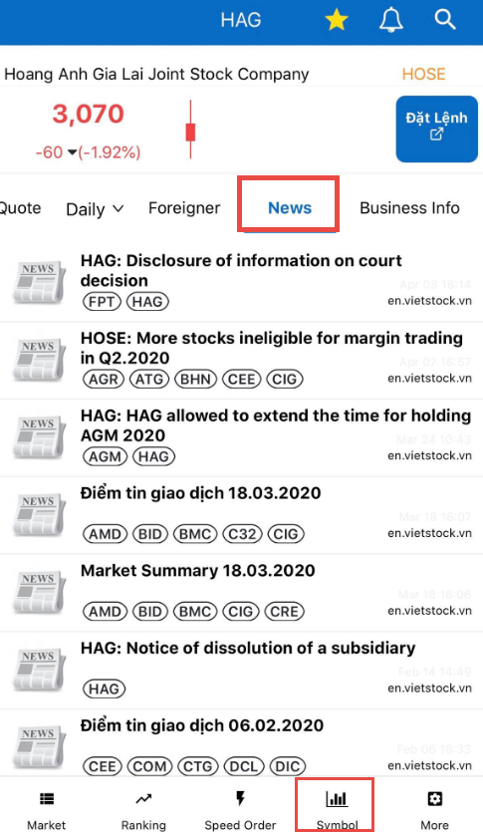

Business info
The screen provides general information of the business publishing the securities codes
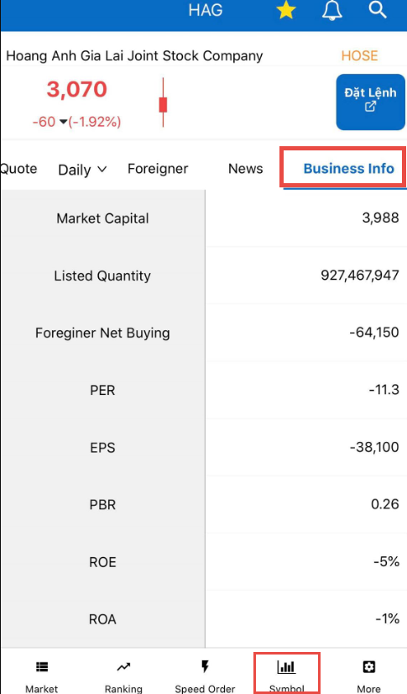

Alarms
Alarms allows customers to track the price and receive notifications immediately when the price of the securities codes touches the tracking price

Create a new alarm
Customers set alarms for securities codes by:
Step 1: Click on and search for the securities codes that customers want to set alarms for it. The system will display the details of the securities codes
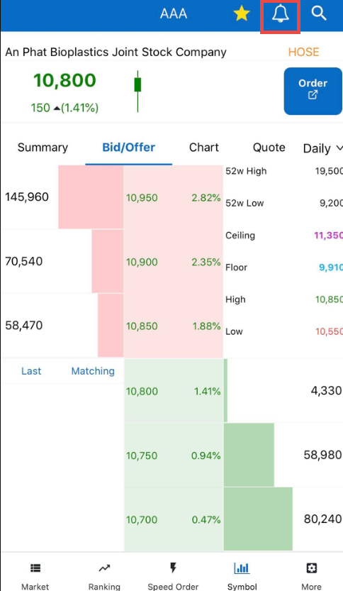
Step 2: Click on at the top right corner of the screen. The system will display a screen to set alarm
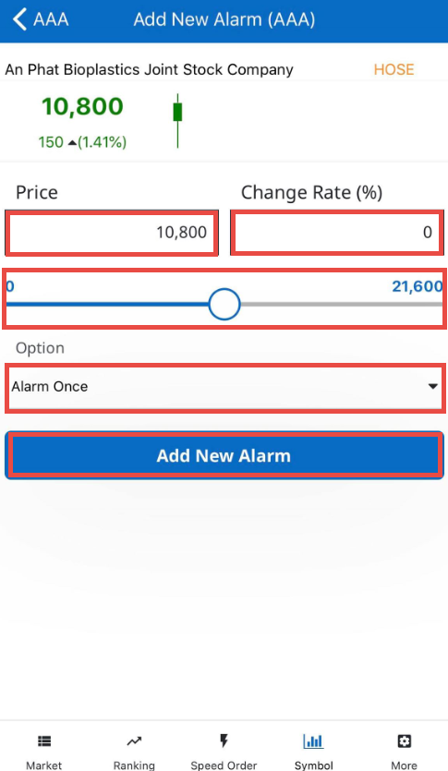
Step 3: Set the “Price” to be alarmed or “Change Rate”. Customers only need to enter one of the fields and the system will automatically fill in the other field. Customers could also move the round symbol of slide bar to increase and decrease the price.
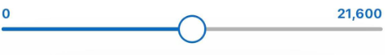
Step 4: Choose “Alarm Once” or “Alarm Multiple” in “Option”
Step 5: Click on “Add New Alarm” to complete setting alarms for the securities codes

Edit and delete alarms
On the Market screen, customers perform the following steps to edit and delete alarms
Step 1: Click on at the top right corner of the Market screen
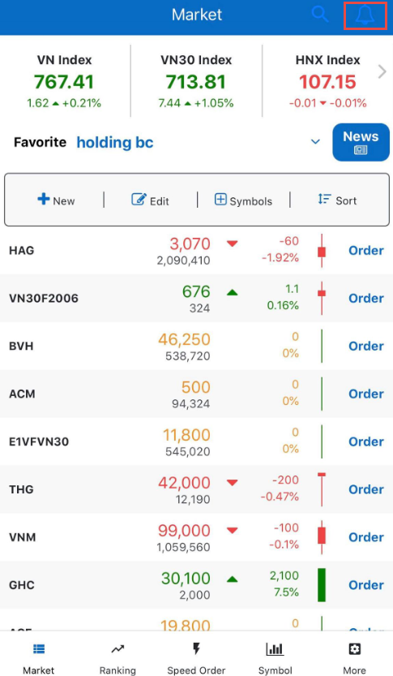
Step 2: Select an act with the alarms list
- Click on 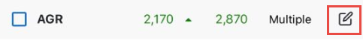 and the screen will go the “Update Alarm” screen. Customers could change the Price or Change Rate or the Option which are “Alarm Once” and “Alarm Multiple”
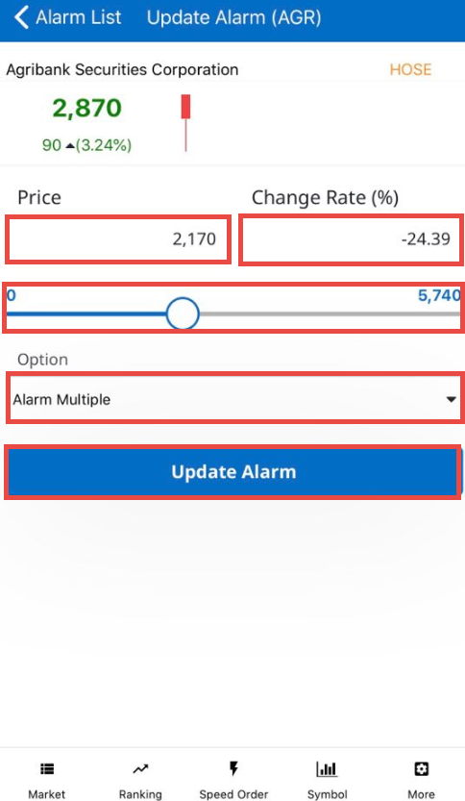
- Customers tick to choose some or “Select all” to choose all alarms available and click on “Delete” to erase the chosen alarms
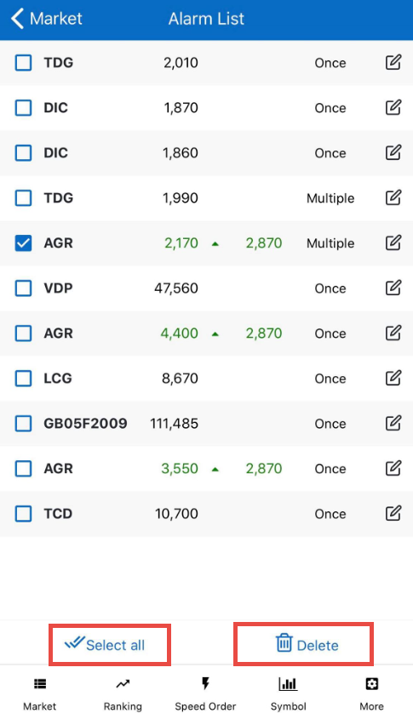

Customer Services

Equity

Stock balance
To lookup for available stock balance and the value of securities, customers click on “More”/ “Stock Balance”
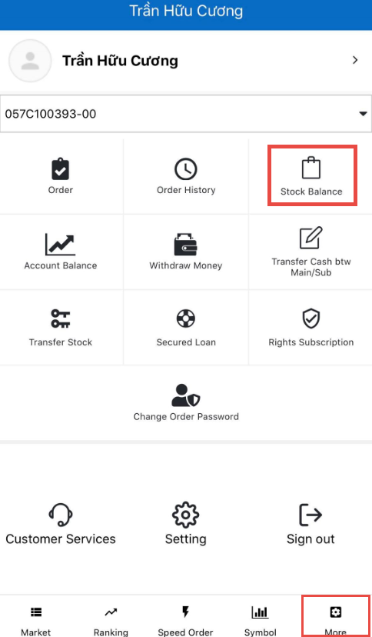
Customer can place sell order by clicking on “Sell” in the front of any securities codes to move to the trading screen
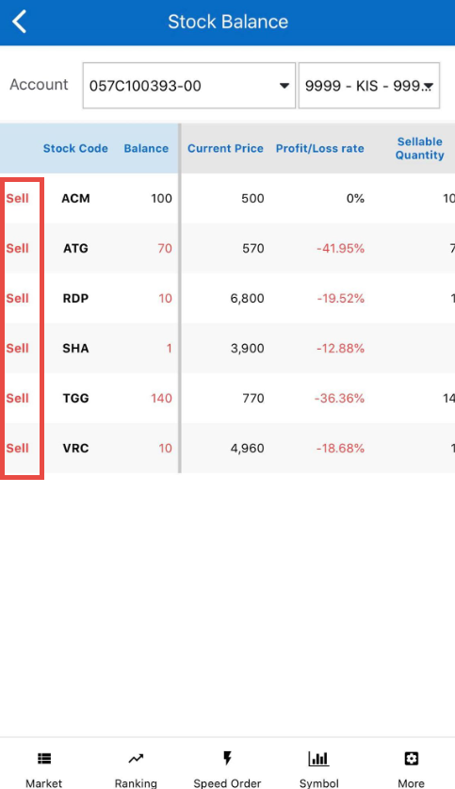

Account balance
Customers lookup for information about their account’s assets and cash on the Account Balance screen
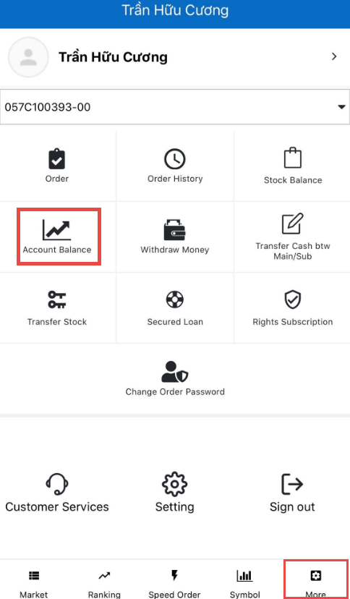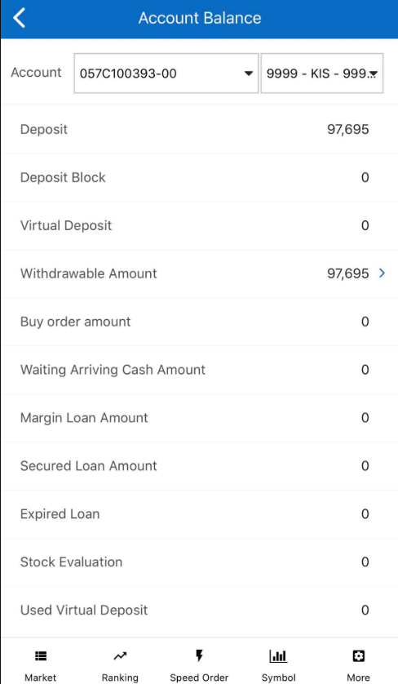

Withdraw money
Customers withdraw money from their account by clicking on “More”/ “Withdraw Money”
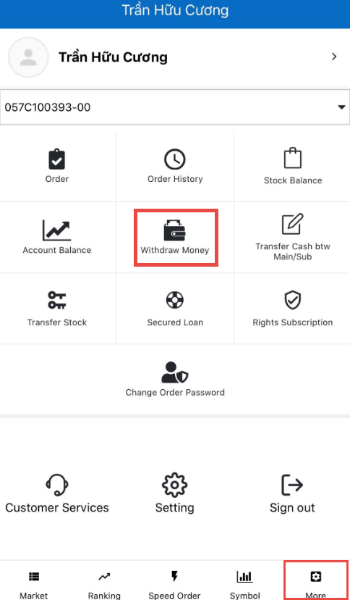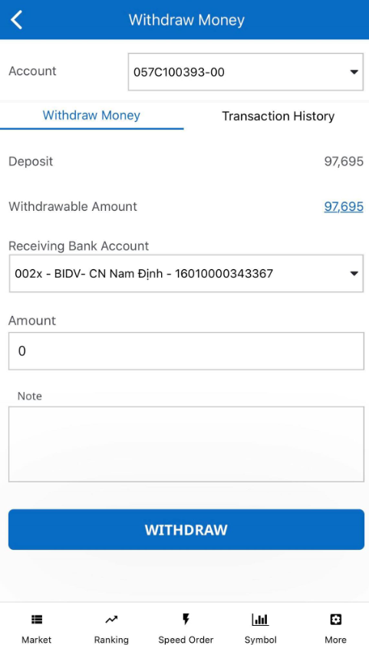
Steps to perform money withdraw from the account:
Step 1: Choose a sub-account to send money to the bank
Step 2: Select an account from “Receiving Bank Account”. The system will display a list of bank accounts that customers have registered at KIS
Step 3: Enter the Amount to withdraw or click on “Withdrawable Amount” and the system will automatically carry the balance to “Amount”. Note: Withdraw Amount cannot exceed the Withdrawable Amount
Step 4: Enter “Note”, this part is optional
Step 5: Click on “Withdraw” to complete
The transaction being made will be displayed at “Transaction History”. Customers will be able to view the transaction status as well as view the transaction history
In terms of transactions having status as “Pending”, customers cancel the transaction by clicking on “Cancel”
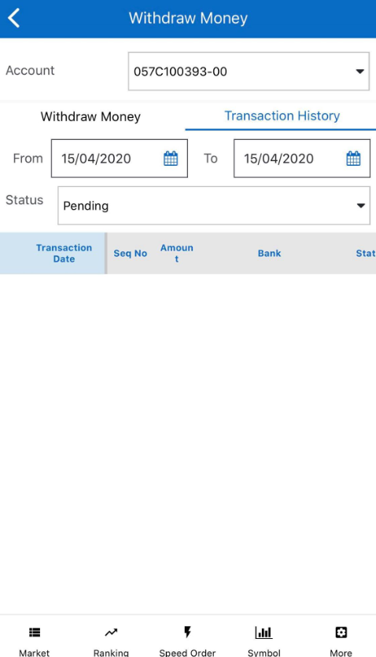

Transfer cash btw main/sub
Customers transfer cash from one sub-account to another by clicking on “More”/ “Transfer Cash btw Main/Sub”

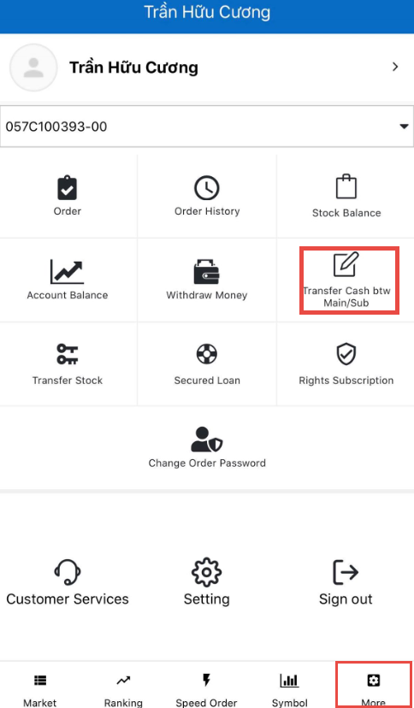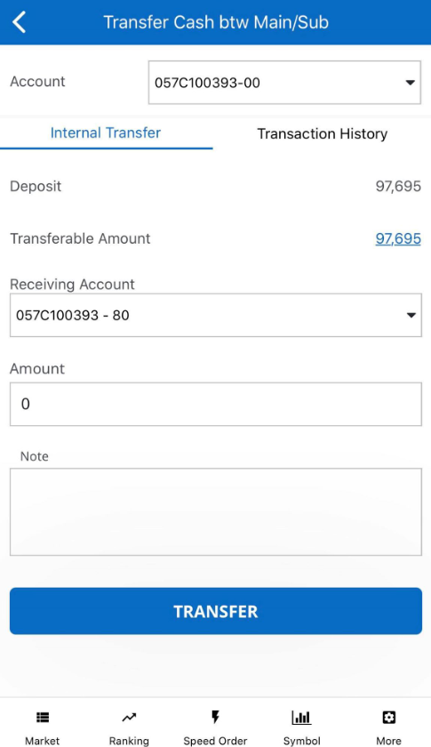

Steps to transfer money to another account:
Step 1: Choose an “Account”
Step 2: Select an account from “Receiving Account”. Customers choose the remaining account
Step 3: Enter the Amount to withdraw or click on “Transferable Amount” and the system will automatically carry the balance to “Amount”. Note: Transfer Amount cannot exceed the Transferable Amount
Step 4: Enter “Note”, this part is optional
Step 5: Click on “Transfer” to complete
The transaction being made will be displayed at “Transaction History”. Customers will be able to view the transaction status as well as view the transaction history
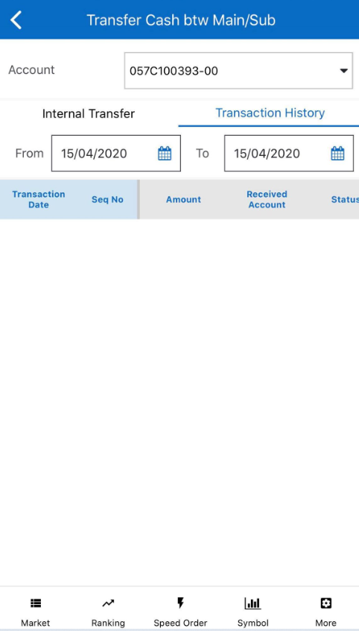

Transfer stock
Customers transfer stock between sub-accounts by clicking on “More”/ “Transfer Stock”
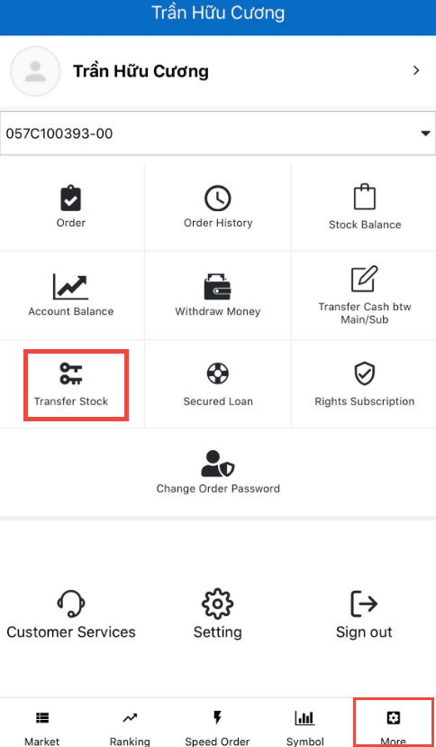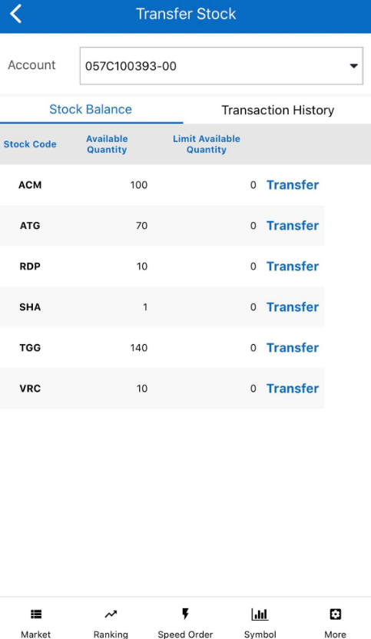
Steps to transfer stock:
Step 1: Click on “Transfer Stock”
Step 2: Select a securities code to transfer or click on “Transfer”. The system will display the Stock Transfer screen.
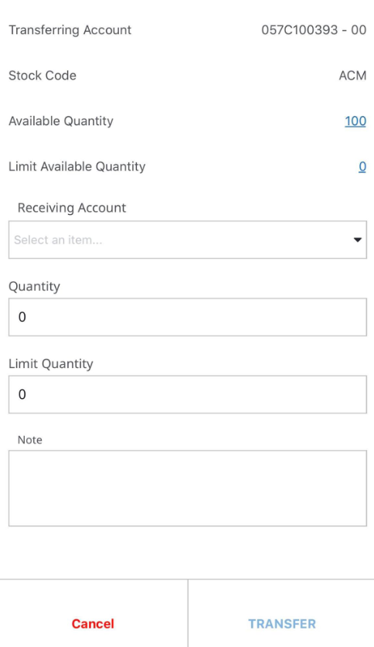
Step 3: Select a “Receiving Account”
Step 4:
- Enter the stock quantity to transfer or click on “Available Quantity” and the system will automatically carry the balance to “Quantity”. Note: Transfer Quantity cannot exceed the Available Quantity
- Enter the limit stock quantity or click on “Limit Available Quantity” and the system will automatically carry the balance to “Limit Quantity”. Note: Limit Quantity cannot exceed the Limit Available Quantity
Step 5: Enter “Note”, this part is optional
Step 6: Click on “Transfer” to complete
The transaction being made will be displayed at “Transaction History”. Customers will be able to view the transaction status as well as view the transaction history
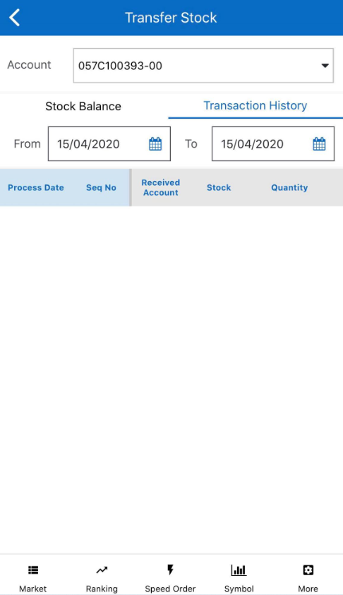

Secured loan
After a sell order is matched, customers advance the selling amount via this screen
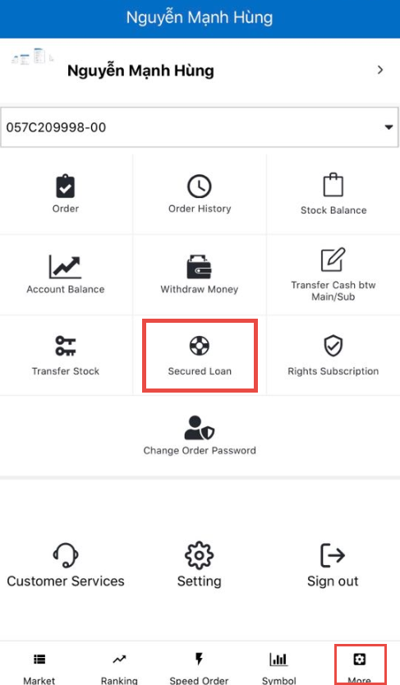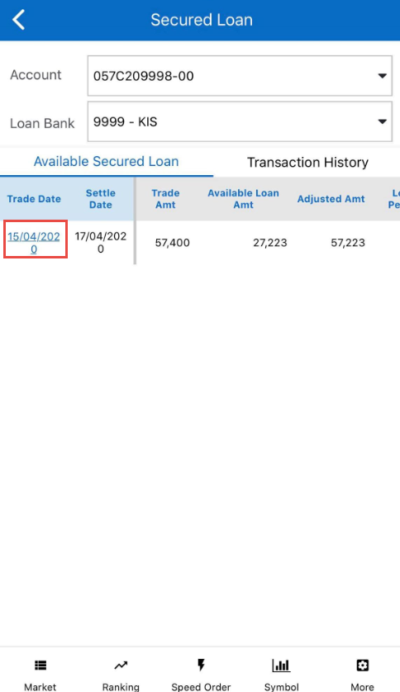

Steps to register secured loan:
Step 1: Click on “Secured Loan”. The system will display all selling amont just matched that customers advance. Customers could click on “Trade Date” to view details of the sell order
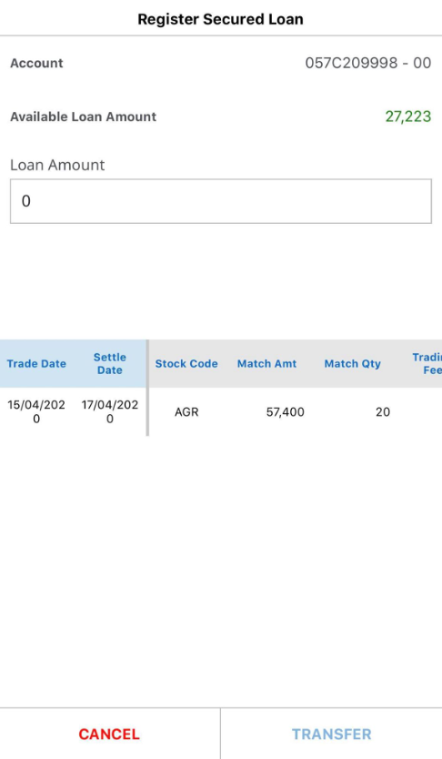
Step 2: Enter the amount to advance. The sysem will set the advance amount with “Available Loan Amount” as default.
Step 3: Click on “Transfer” to complete registering secured loan
The newly created loan will be displayed in “Transaction History”. Customers will be able to view the transaction status as well as view its details
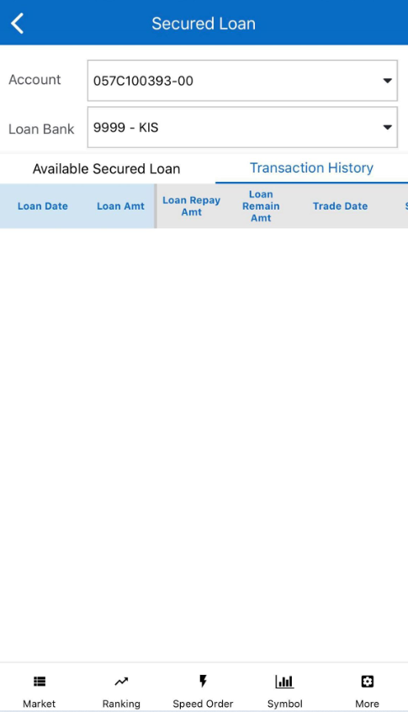

Rights subscription
This screen helps customers register rights subscription for additional stocks and buy bonds online when they have rights to the securities code they hold

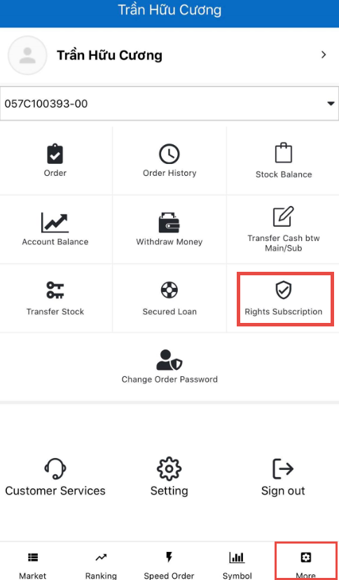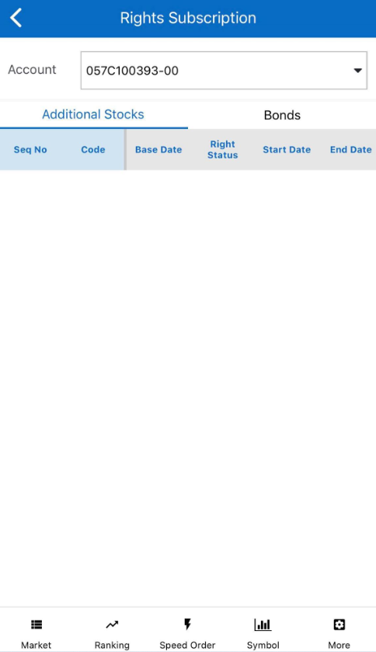

Derivatives

Derivatives information
Customers lookup for information about balance, collateral securities and non-collateral securities of derivatives account (sub-account 80)
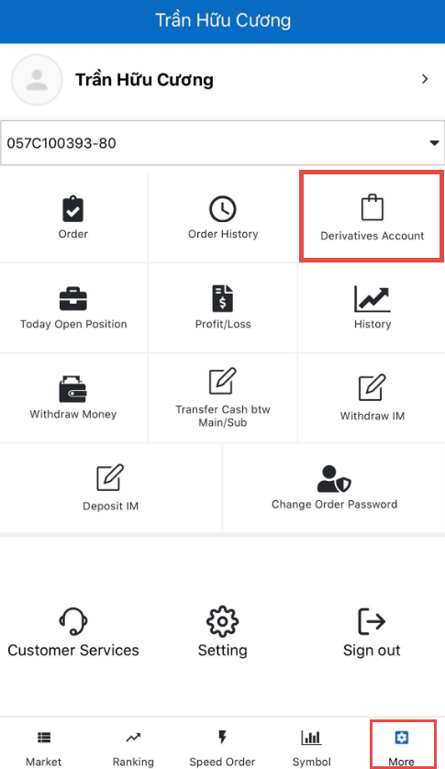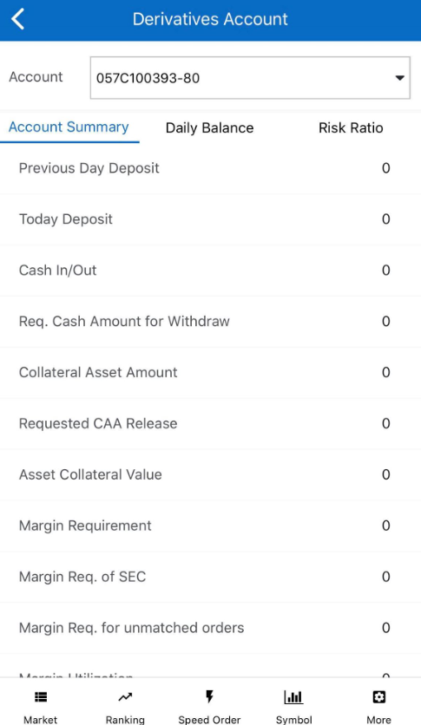

Daily balance
Customers lookup for cash balance and margin securities by clicking on “More”/ “Derivatives Account”/ Daily Balance

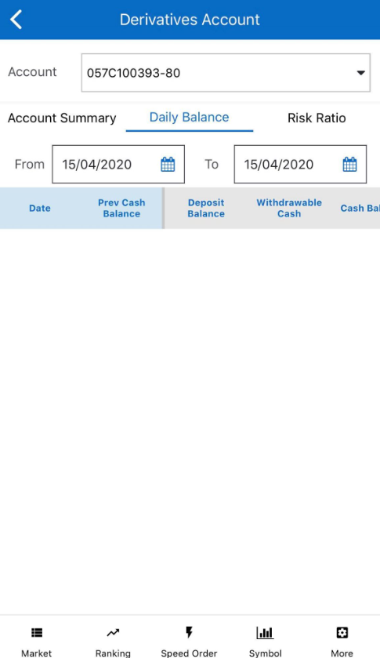

Risk ratio
Customers lookup for margin usage ratio of the account and based on the figures, cusomers could make plan to use margin asset more effectively. Click on “More”/ “Derivatives Account”/ Rish Ratio

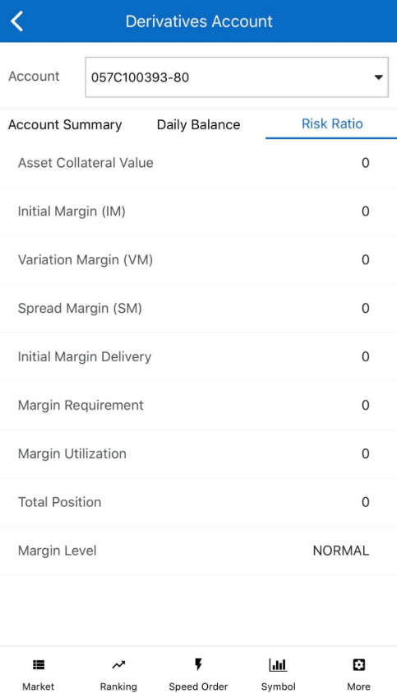

Today open positions
Customers lookup for open positions during the day by clicking on “More”/
Today Open Positions”
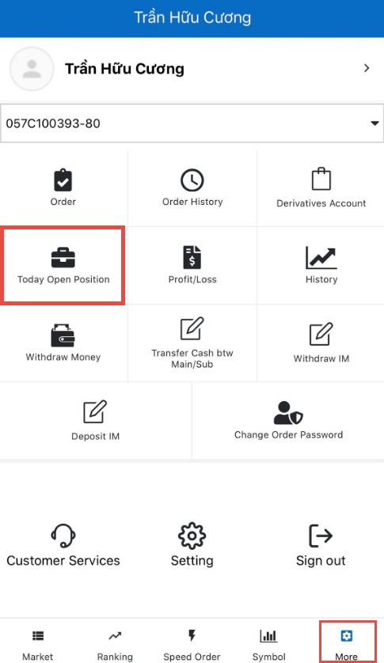

Daily profit/loss and cumulative profit/loss
Customers are ale to lookup for profit/loss value based on the current price (closing price) of the account by clicking on “More”/ “Profit/Loss”

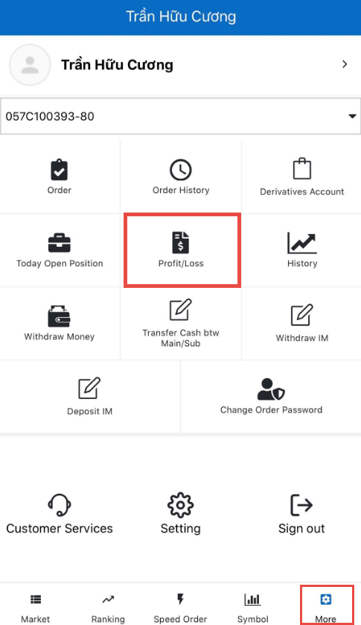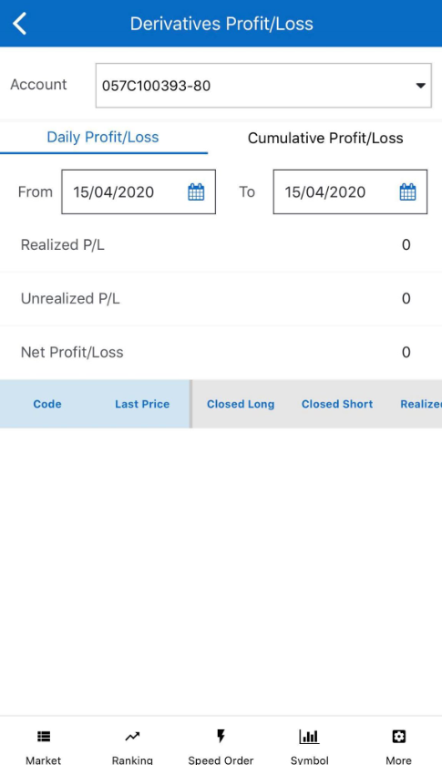
Or Cumulative Profit/Loss
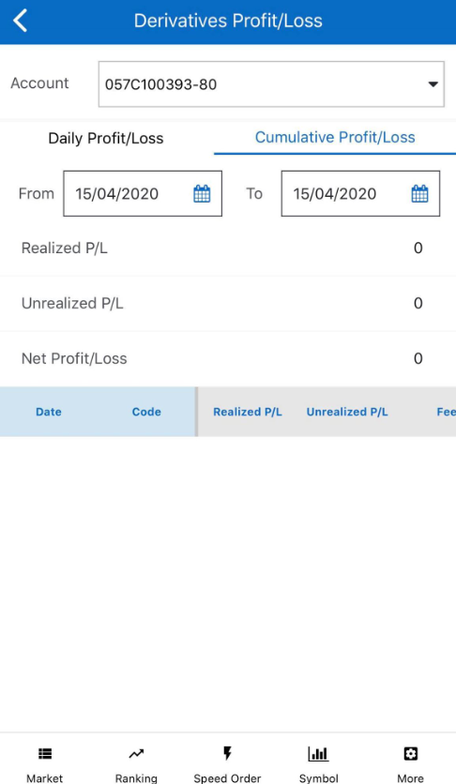

History
Margin call
Customers lookup for margin call history of the account and the status that whether there is by clicking on “More”/ “History”/ Margin Call

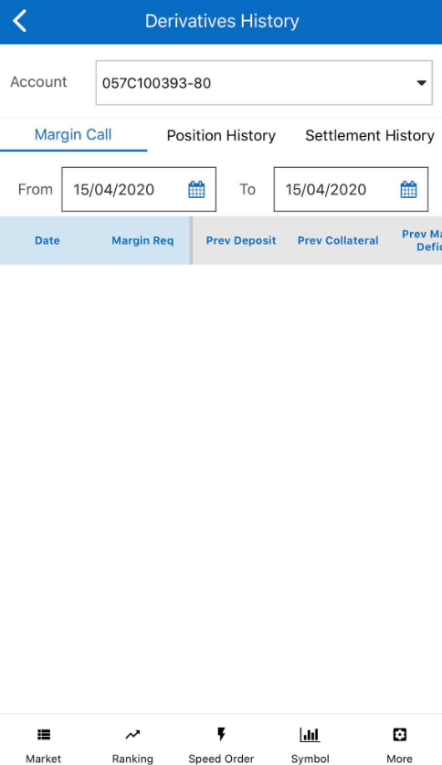
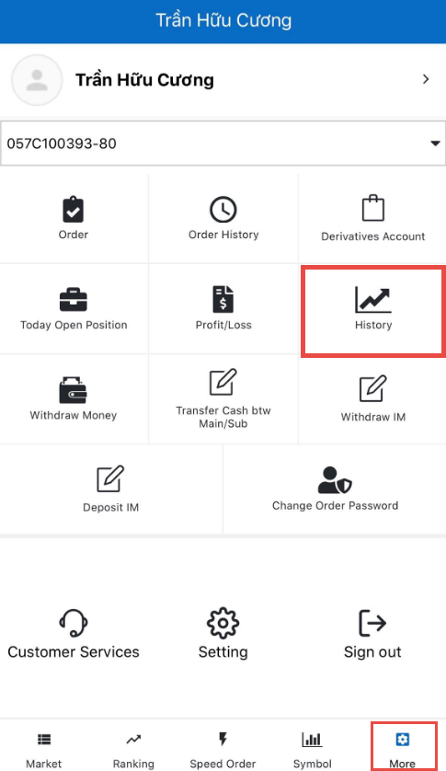
Position history
Customers lookup for position history of customer’s account in the day by clicking on “More”/“History”/Position History

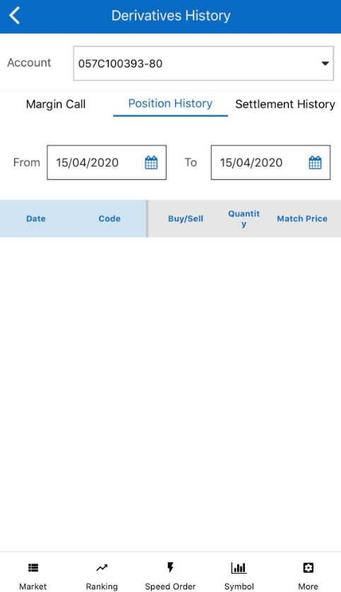
Settlement history
Customers lookup for account’s history of settling position profit/loss by clicking on “More”/“History”/Settlement History

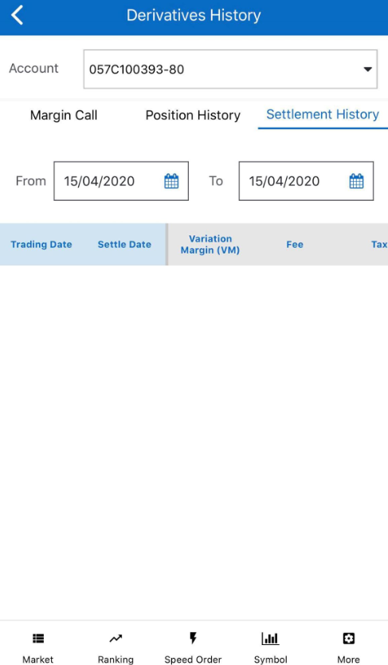

Withdraw money
Customers perform transferring money that hasn’t been used for derivatives margin purposes via bank account registered by clicking on “More”/“Withdraw Money”

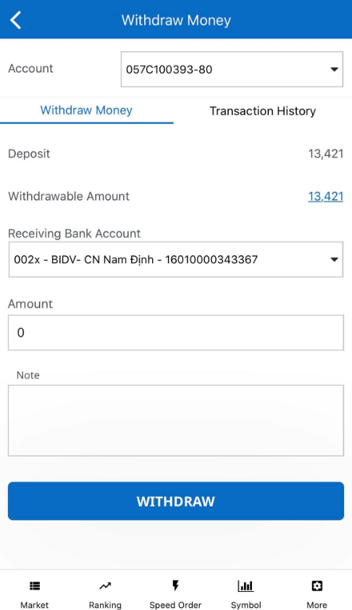
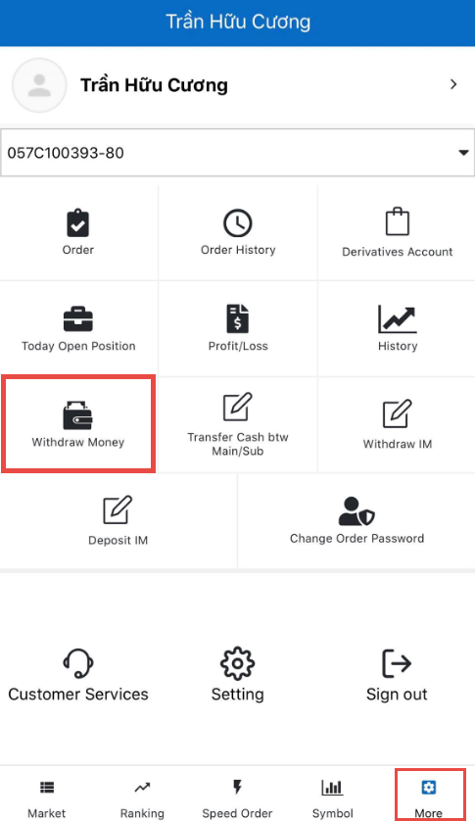
Steps to perform money withdraw from the derivatives account:
Step 1: Choose the sub-account 80
Step 2: Choose “Receiving Bank Account”.
Step 3: Enter the Amount to withdraw or click on “Withdrawable Amount” and the system will automatically carry the balance to “Amount”.
Step 4: Enter “Note”, this part is optional
Step 5: Click on “Withdraw” to complete
The transaction being made will be displayed at “Transaction History”. Customers will be able to view the transaction status as well as view the transaction history
In terms of transactions having status as “Pending”, customers cancel the transaction by clicking on “Cancel”
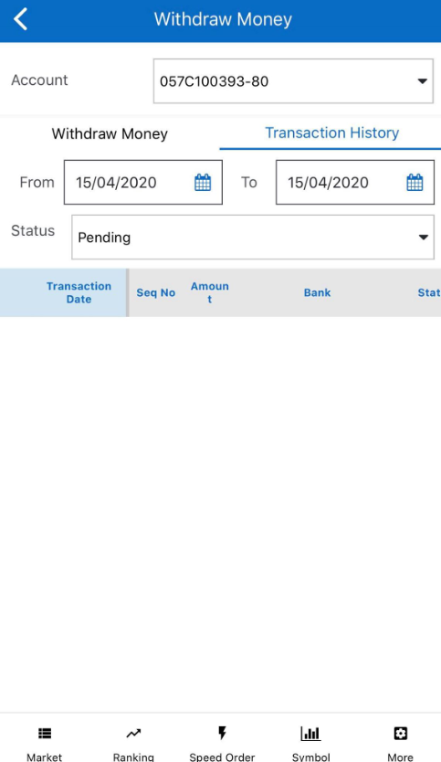

Transfer cash btw main/sub
Customers transfer cash from the derviatives account to other sub-accounts by clicking on “More”/ “Transfer Cash btw Main/Sub”
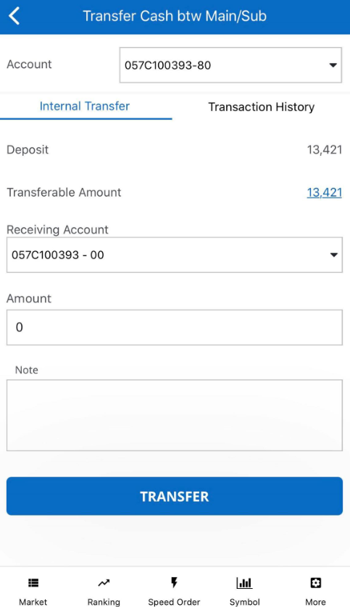
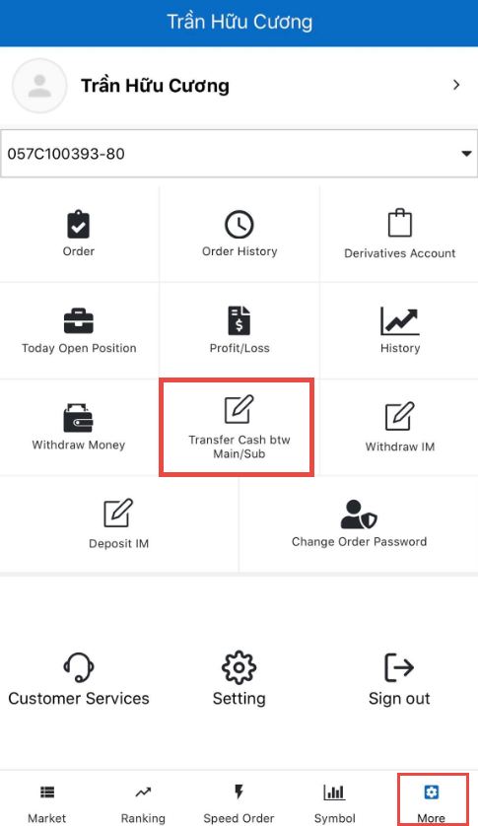
Steps to transfer money:
Step 1: Choose the sub-account 80
Step 2: Choose a “Receiving Account”
Step 3: Enter the Amount to withdraw or click on “Transferable Amount” and the system will automatically carry the balance to “Amount”.
Step 4: Enter “Note”, this part is optional
Step 5: Click on “Transfer” to complete
The transaction being made will be displayed at “Transaction History”. Customers will be able to view the transaction status as well as view the transaction history
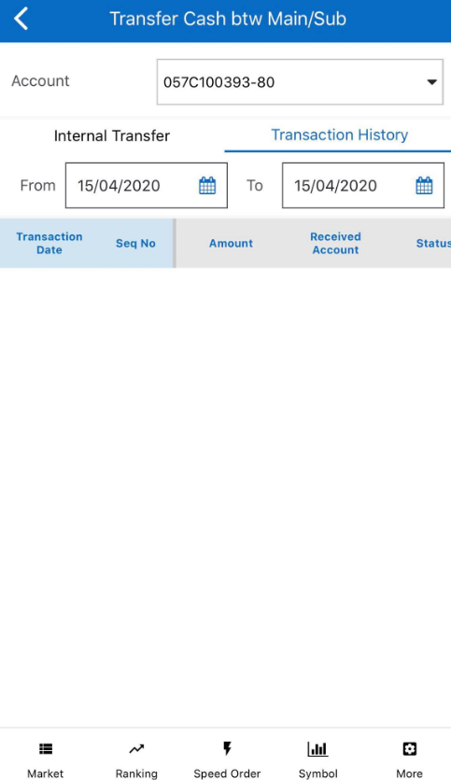

Deposit IM
Customers deposit more initial margin by clicking on “More”/“Deposit IM”
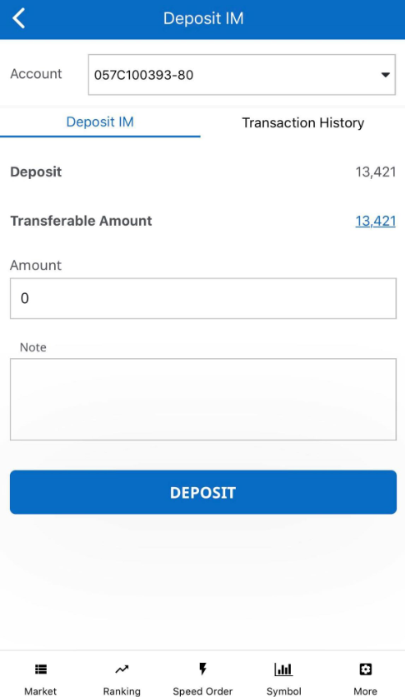
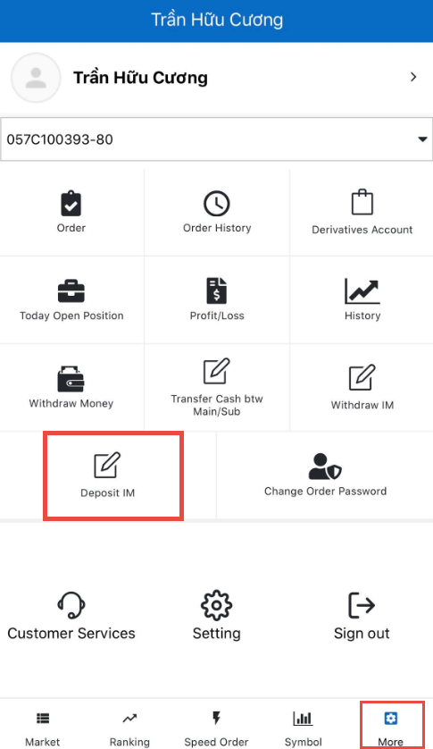
Steps to deposit IM:
Step 1: Choose the “Account” to deposit IM
Step 2: Enter the “Amount”
Step 4: Enter “Note”, this part is optional
Step 5: Click on “Deposit” to complete
The transaction being made will be displayed at “Transaction History”. Customers will be able to view the transaction status as well as view the transaction history
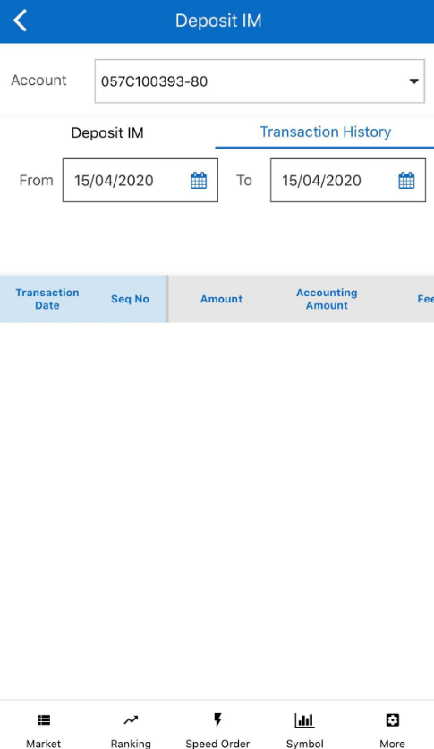

Withdraw IM
Customers withdraw initial margin by clicking on “More”/“Withdraw IM”
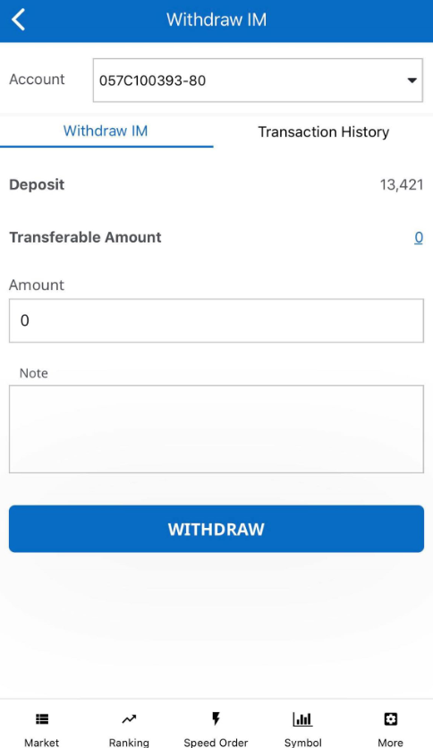
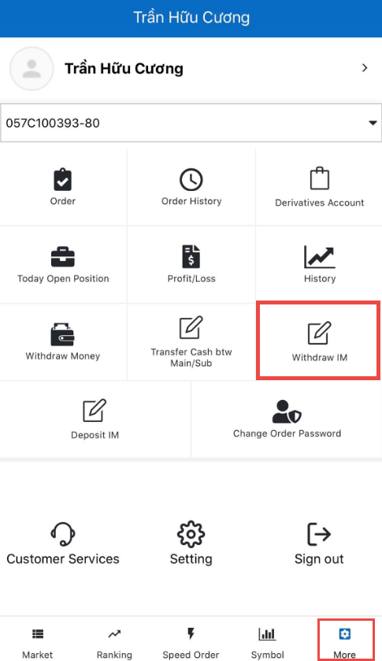

Steps to withdraw IM:
Step 1: Choose the “Account”
Step 2: Enter the Amount to withdraw or click on “Transferable Amount” and the system will automatically carry the balance to “Amount”
Step 4: Enter “Note”, this part is optional
Step 5: Click on “Withdraw” to complete
The transaction being made will be displayed at “Transaction History”. Customers will be able to view the transaction status as well as view the transaction history
